**HIGHLY EFFICIENT AND SUSTAINABLE CuO / g–C3N4 COMPOSITES FOR ANTIBACTERIAL ACTIVITY AND THE ORGANIC DEGRADATION**

**A PROJECT REPORT**

*Submitted by*

**JIVITHA S (Reg No: 510421214020)**

**PRIYADHARSHINI R (Reg No:510421214034)**

*In partial fulfilment for the award of the degree*

*of*

**BACHELOR OF TECHNOLOGY**

**IN**

**BIOTECHNOLOGY**

**ARUNAI ENGINEERING COLLEGE**

**(Autonomous)**

**TIRUVANNAMALAI – 606603**

**MAY 2025**

**ANNA UNIVERSITY: CHENNAI-600025**



### **Bonafide Certificate**

Certified that this project report “**HIGHLY EFFICIENT AND SUSTAINABLE CuO/ g–C3N4 COMPOSITE FOR ANTIBACTERIAL ACTIVITY AND THE ORGANIC DEGRADATION”** is the bona fide work of **“JIVITHA S (Reg.no: 510421214020) PRIYADHARSHINI R (Reg.no:510421214034)”** carriedout the project work under my supervision.

## **SIGNATURE SIGNATURE**

Prof.R. PRAVEEN KUMAR. Dr. J. VINOTH ARUL RAJ

###### **HEAD OF THE DEPARTMENT SUPERVISOR**

Department of Biotechnology Department of Biotechnology

Arunai Engineering College Arunai Engineering College

Tiruvannamalai                                                 Tiruvannamalai

The viva voce examination held on: ……………

**INTERNAL EXAMINER EXTERNAL EXAMINER**

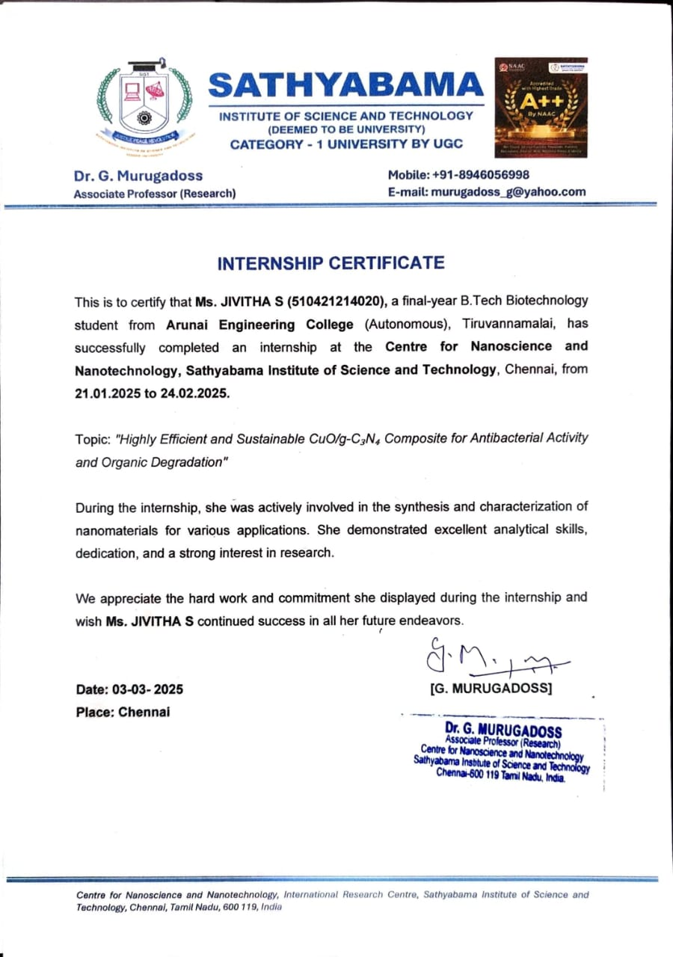

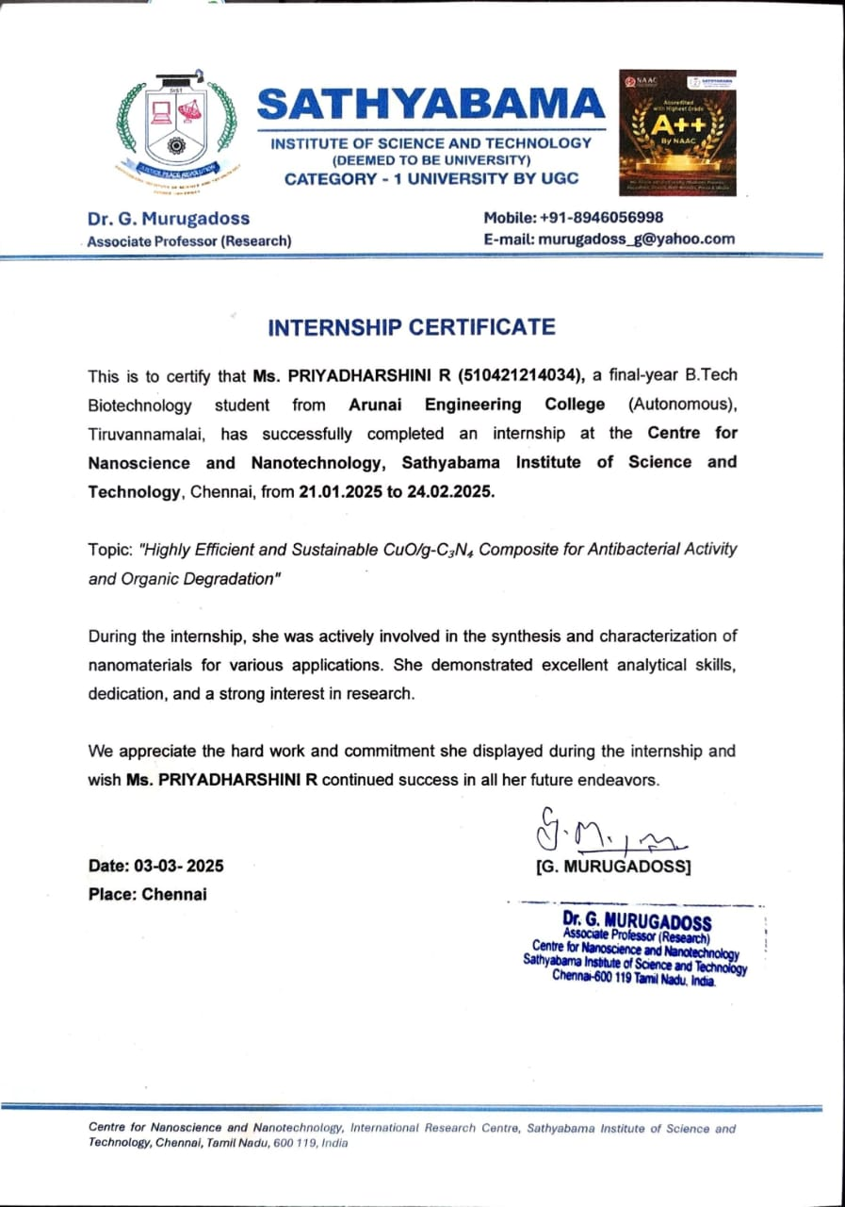

### **ACKNOWLEDGEMENT**

We express our profound gratitude to our founder Chairman Thiru**. E. V. VELU**, Vice-Chairman **Er. E. V. KUMARAN** and our Principal **Dr. C. Elanchezhian**, and our registrar **Dr. R. SATHIYASEELAN** for providing their appreciation and facilities made the experience a pleasant one.

We are very grateful to our Head of the Department

**Mr. R. PRAVEEN KUMAR** who constantly worked for the development of our department. We express our sincere thanks to our Project Guide,

**Dr. MURUGADOSS GOVINDHASAMY**, Scientist, Sathyabama Institute of Science and Technology, Chennai, for his valuable input, able guidance, encouragement, whole-hearted cooperation and constructive criticism throughout the duration of our project. Also, we thank our Internal guide

**Dr. J. VINOTH ARULRAJ** Assistant Professor for his uninterruptable suggestions and words of improvement regarding our project. Special thanks to **Dr. K. DHANARAJ** for his constant input in seeding us the project idea and his knowledge to complete the project. We would like to extend our gratitude to Sathyabama Institute of Technology for providing us with every requirement.

Sincerely we thank all the faculty members and Lab Technicians of our Department for their constant support, Encouragement and Guidance through our period of study, without which hitting this mark of success would have been a layman’s dream.Protected by the Omnipotent powers of the Almighty, together with the blessings, unconditional support and encouragement of our parents we have succeeded in completing this project. It is our dignity to dedicate this project to them.

**JIVITHA PRIYADHARSHINI R**

### **DECLARATION**

We declare that the dissertation entitles “**HIGHLY EFFICIENT AND SUSTAINABLE CuO / g–C3N4 COMPOSITES FOR ANTIBACTERIAL ACTIVITY AND THE ORGANIC DEGRADATION”** submitted to the Anna University, Chennai for the award of the degree of Bachelor of Technology is an original record of research work carried out by us under the supervision of

**Dr. Murugadoss Govindhasamy**, Sathyabama Institute of Science and Technology. The contents of this dissertation, in full or in parts, have not been submitted to any other Institute or University for the award of any degree or diploma, membership, fellowship, associateship etc. In keeping with the general practice in reporting scientific observation, due acknowledgement has been made whenever the work described is based on the findings of other investigators.

Place: Tiruvannamalai Date:

We hereby declare that the above-mentioned details are true to our knowledge.

**(JIVITHA S)**

**(PRIYADHARSHINI R)**

**ABSTRACT**

In this study, copper oxide (CuO) nanoparticles were successfully synthesized and integrated with graphitic carbon nitride (g-C₃N₄) to form a CuO/g-C₃N₄ nanocomposite via a simple co-precipitation method. g-C₃N₄ served as a stable, visible-light-active semiconductor support, while CuO imparted strong photocatalytic and antibacterial functionalities. The structural and morphological characteristics of the synthesized nanocomposites were systematically analyzed using X-ray diffraction (XRD), X-ray photoelectron spectroscopy (XPS), and Field Emission Scanning Electron Microscopy (FESEM) coupled with Energy Dispersive Spectroscopy (EDS), confirming the formation of a well-dispersed CuO phase over the g-C₃N₄ sheets with improved surface area and interfacial contact. The antibacterial efficacy of the composite was assessed using disc diffusion assays against bacterial pathogens including *Escherichia coli*, *Staphylococcus aureus*, *Bacillus subtilis*, and *Klebsiella pneumoniae*. The CuO/g-C₃N₄ nanocomposite demonstrated substantial zones of inhibition compared to controls and standard antibiotics, highlighting its broad-spectrum antibacterial potential, primarily due to the generation of reactive oxygen species (ROS) that disrupt microbial membranes. Furthermore, the photocatalytic degradation of synthetic dyes such as Fast Green under visible light irradiation revealed that the CuO/g-C₃N₄ composite exhibited markedly higher degradation efficiency than pristine CuO or g-C₃N₄ alone, attributed to the synergistic interaction between CuO and g-C₃N₄ which enhances charge carrier separation, reduces recombination rates, and extends light absorption. In addition to its environmental and antimicrobial capabilities, the composite also showed dose-dependent cytotoxic effects against HeLa cells in MTT assays, supporting its potential in biomedical applications.

**Table Of Contents**

|  |  |  |
| --- | --- | --- |
| **Chapter No.** | **Title** | **Page No.** |
| **Content:** | Abstract | VII |
|  | List of Tables | XI |
|  | List of Figures | XII |
|  | List of Symbols | XIII |
|  | List of Abbreviation | XIV |
| 1. | INTRODUCTION | 1 |
|  | 1.1 value of water | 1 |
|  | 1.2 Causes of Pollution | 1 |
|  | 1.3 Impact on environment and health | 2 |
|  | 1.4 Organic pollutants | 3 |
|  | 1.5 Materials | 4 |
|  | 1.5.1 Nanomaterials | 4 |
|  | 1.5.2 Types | 5 |
|  | 1.5.3 Unique properties of Nanomaterials | 6 |
|  | 1.5.4 Application of Nanomaterials | 6 |
|  | 1.5.4.1 Environmental Applications | 7 |
|  | 1.5.4.2 Biomedical and antibacterial applications | 7 |
|  | 1.6 Composite Materials | 8 |
|  | 1.7 Biomaterials | 8 |
|  | 1.7.1 Nontoxicity | 8 |
|  | 1.8 Copper Oxide Nanoparticle | 9 |
|  | 1.8.1 Properties of copper Oxide | 10 |
|  | 1.9 Graphitic Carbon Nitride (g–C3N4 ) | 10 |
|  | 1.10 Photocatalytic Activity | 12 |
|  | 1.11 Semiconductor Photocatalysis | 14 |
|  | 1.11.1 Mechanism of Photocatalytic Reactions | 14 |
|  | 1.11.2 Role of band gap in Photocatalysis | 15 |
|  | 1.11.3 Photocatalytic Degradation | 15 |
|  | 1.12 Characterization | 16 |
| 2. | REVIEW OF LITERATURE | 18 |
|  | 2.1 CuO/g-C₃N₄ composites for degradation of organic pollutants | 18 |
|  | 2.2 Photocatalytic properties and antibacterial activity of CuO/g-C₃N₄ composites | 18 |
|  | 2.3 Design of Type-II and Z-Scheme Heterojunctions in CuO/g-C₃N₄ composites | 18 |
|  | 2.4 Photocatalytic performance and stability of CuO/g-C₃N₄ composites | 19 |
|  | 2.5 Photocatalytic degradation and antibacterial performance | 19 |
|  | 2.6 Synthesis and characterization of CuO/g-C₃N₄ composites | 20 |
| 3. | MATERIALS AND METHOD | 21 |
|  | 3.1 Synthesis of CuO / g-C₃N₄ Nanocomposite | 21 |
|  | 3.2 X-Ray diffraction | 22 |
|  | 3.2.1 Determination of crystal size | 22 |
|  | 3.2.2 Determination of lattice parameters | 23 |
|  | 3.2.3 Sample preparation | 23 |
|  | 3.3 X-ray photoelectron spectroscopy | 24 |
|  | 3.4 FE-SEM and XRD | 25 |
|  | 3.4.1 Instrument details | 26 |
|  | 3.4.2 Methodology | 26 |
|  | 3.4.3 Sample Preparation | 27 |
|  | 3.4.4 Analytical procedure | 27 |
|  | 3.5 Antibacterial Assay | 28 |
|  | 3.5.1 Disc preparation | 28 |
|  | 3.5.2 Collection of test bacteria | 28 |
|  | 3.5.3 Assay of Antibaterial Activity | 28 |
|  | 3.6 Photocatalytic Activity | 29 |
|  | 3.6.1 Photocatalytic organic degradation | 29 |
|  | 3.6.2 Analysis of degradation efficiency | 30 |
|  | 3.6.3 Reusability and stability test | 30 |
|  | 3.7 Anticancer activity | 31 |
|  | 3.7.1 Materials and Reagents | 31 |
|  | 3.7.2 Cell culture | 31 |
|  | 3.7.3 Preparation of Nanocomposite Suspensions | 31 |
|  | 3.7.4 MTT Cytotoxicity Assay | 32 |
|  | 3.7.5 Determination of IC50 value & SD | 32 |
| 4. | RESULTS AND DISCUSSION | 34 |
|  | 4.1 Synthesis of CuO /g-C3N4 Nanocomposite | 34 |
|  | 4.2 Characterization | 35 |
|  | 4.2.1 Energy-Dispersive X-ray Spectroscopy (EDS) | 35 |
|  | 4.2.2 Field Emission Scanning Electron Microscopy (FESEM) | 39 |
|  | 4.2.3 X-ray diffraction | 41 |
|  | 4.2.3.3 XRD Pattern of CuO /g-C3N4 | 43 |
|  | 4.2.4 X-ray photoelectron spectroscopy (XPS) | 43 |
|  | 4.2.5 Fourier Transform Raman spectroscopy | 47 |
|  | 4.3 Application | 50 |
|  | 4.3.1 Antibacterial Assay | 50 |
|  | 4.3.2 Anticancer Activity | 52 |
|  | 4.3.3 Photocatalytic Activity | 55 |
| 5. | CONCLUSION | 59 |
| 6. | REFERENCES | 60 |

LIST OF TABLES

|  |  |  |
| --- | --- | --- |
| Table No. | Tables | Page No. |
| 4.1 | Elemental composition of CuO /g-C3N4 based on EDS analysis | 35 |
| 4.2 | Raman Peak Assignments for CuO/g-C₃N₄ Composite Indicating Characteristic Vibrational Modes | 48 |
| 4.3 | Table Zone of Inhibition (mm) of CuO/g-C₃N₄ Nanocomposite Against Pathogenic Bacterial Strains at Different Concentrations | 50 |
| 4.4 | Time-Dependent Absorbance and Degradation Efficiency of Methyl Orange Using CuO Under Visible Light | 57 |
| 4.5 | Time-Dependent Absorbance and Degradation Efficiency of Methyl Orange Using g-C₃N₄ Under Visible Light | 58 |

LIST OF FIGURES

|  |  |  |
| --- | --- | --- |
| Figure No. | Title | Page No. |
| 1.1 | Types of nanomaterials | 5 |
| 1.2 | Application of Nanomaterial | 7 |
| 1.3 | Basic principle of photocatalysis | 15 |
| 4.1 | Synthesized g-C3N4(GC) Composite Suspension | 34 |
| 4.2 | EDS Spectrum of CuO/g-C3N4 Composite | 36 |
| 4.3 | EDS Elemental Mapping of CuO/g-C3N4 Composite | 36 |
| 4.4 | FE SEM image of pristine g-C3N4 | 39 |
| 4.5 | FESEM image of CuO/g-C3N4 Composite | 39 |
| 4.6 | XRD Pattern of pristine g-C3N4 | 41 |
| 4.7 | XRD Pattern of synthesized CuO nanoparticles | 41 |
| 4.8 | XRD Pattern of CuO/g-C3N4 Composite | 42 |
| 4.9 | XPS Survey Spectrum of CuO/g-C3N4 Composite | 44 |
| 4.10 | Cu2p XPS spectrum of CuO/g-C3N4 Composite | 45 |
| 4.11 | O1s XPS spectrum of CuO/g-C3N4 Composite | 45 |
| 4.12 | C1s XPS spectrum of CuO/g-C3N4 Composite | 46 |
| 4.13 | FT RAMAN Spectrum of pristine g-C3N4 | 48 |
| 4.14 | FT RAMAN Spectrum of pristine CuO/ g-C3N4 | 49 |
| 4.15 | FTRAMAN Analysis of CuO/ g-C3N4 Composite | 49 |
| 4.16 | Antibacterial Activity of CuO/g-C3N4 Nanocomposite | 51 |
| 4.17 | Phase-contrast microscopic images of HeLa cells treated with CuO/ g-C3N4 Composite | 52 |
| 4.18 | UV-Vis absorption spectra of CuO/g-C3N4 | 55 |
| 4.19 | UV-Vis absorption spectra of methyl orange during photocatalytic degradation using CuO at different time interval | 55 |

LIST OF SYMBOLS

|  |  |
| --- | --- |
| Symbol | Explanations |
| Cu | Copper |
| N2 | Nitrogen |
| C | Carbon |
| O2 | Oxygen |
| CO2 | Carbondioxide |
| H2O | Water |
| TiO₂, | Titanium oxide |
| ZnO, | Zinc oxide |
| SnO₂ | Tin oxide |
| CuO | Copper Oxide |
| ZnO | Zinc oxide |
| g-C3N4 | Graphitic carbon nitride |
| CdS, | Cadmium sulphide |
| SnS2 | Tin disulphide |
| Fe2O3 | Iron(III) oxide |
| µg/mL | microgram per millilite |
| % | Percentage |
| keV | kiloelectron volt |
| Lβ | L-beta X-ray |
| eV | electron volt |
| Nm | Nanometre |
| (°) | Degree |
| NaOH | Sodium Hydroxide |
| (e⁻) | Electrons |
| eV | Electron volt |

LIST OF ABBREVIATIONS

|  |  |
| --- | --- |
| Abbreviation | Expansion |
| PGA | Poly (glycolic acid) |
| PMMA | Polymethylmethacrylate |
| PVP | Polyvinylpyrrolidone |
| PVA | Polyvinyl alcohol |
| PEG | Polyethylene glycol |
| PMCs | polymer matrix composites |
| Rh B | Rhodamine B |
| MB | Methylene blue |
| MO | Methyl orange |
| CV | Crystal violet |
| MMCs | metal matrix composites (MMCs), |
| CMCs | ceramic matrix composites (CMCs). |
| DDS | Drug delivery systems |
| Np | Nano Powders |
| Nps | Nano Particles |
| NGs | Nano Gels |
| NS | Nano Sheets |
| Nqs | Nano Quantum |
| NTs | Nanotubes |
| Mox | Metal Oxide |
| MVI | Microwave Irradiation |
| ROS | Reactive Oxygen Species |
| CB | Conduction Band |
| 2D | Two-Dimensional |
| AOPs | Advanced Oxidation Processes |
| •OH | Hydroxyl Radicals |
| UV | Ultra violet |
| ROS | Reactive Oxygen Species |
| XRD | X-ray diffraction |
| FE-SEM | Field Emission Scanning Electron Microscopy |
| TEM | Transmission Electron Microscopy |
| FTIR | Fourier Transform Infrared Spectroscopy |
| PVP | Poly Vinyl Pyrrolidone |
| FWHM | Full Width at Half Maximum |
| FT Raman | Fourier Transform Raman |
| XPS | X-ray Photoelectron Spectroscopy |

**CHAPTER 1**

**1 INTRODUCTION**

**1.1 WATER POLLUTION CRISIS**

Human survival and development depend on water. around the past 50 years, freshwater resources have been in danger all around the world. When non-potable contaminants are discharged into freshwater sources, it is referred to as water pollution. These pollutants are considered harmful to people, animals, their ecosystems, and the environment. They also deplete clean water supplies. Water contamination has become a global issue due to rapid population increase and development. Leather products, paper, paints, cosmetics, and textiles are among the industries that release millions of color effluents into the lake (Aslam et al., 2024)Drinking water supplies have been contaminated and depleted in large part by the textile and pharmaceutical industries. Both aquatic and human life are seriously threatened by untreated wastewater (Vignesh et al., 2024). Numerous microbiological and chemical toxins that are detrimental to human health are discharged into the environment on a daily basis. Microbes and chemical pollutants can interact in complex and unforeseen ways that can have serious effects on the environment. Therefore, it is essential to create eco-friendly methods for appropriately breaking down pollutants (Faraji et al., 2018)

**1.2 CAUSES OF POLLUTION**

Demand for environmental relief and new forms of energy has increased as a result of the constantly growing industries, deforestation, use of nonrenewable energy sources, etc. Climate change, water pollution, and air pollution were caused by deforestation and the buildup of industrial waste. As a result, there is now a greater need to remediate and prevent water pollution. Numerous techniques, including adsorption, membrane separation, flotation, etc., are used to treat contaminated water. However, the secondary wastes produced by these techniques necessitate the use of additional treatment techniques, which drives up expenses. For these reasons, attempts have been made to remove organic contaminants using Advanced Oxidation Processes (AOPs). The most efficient technique for adjusting bandgap and catalytic activity among the previously listed approaches is metal doping. It increases both the particular active surface area and the amount of visible light (Chellakannu et al., 2024)

Large volumes of heavy metal ions, radionuclides, pesticides, personal care products, and persistent organic pollutants are unavoidably released into the environment due to the rapid development of industry, urbanization, and agriculture. These environmental contaminants are harmful to human health and, in the absence of natural conditions, are difficult or impossible to break down into less harmful substances (Chen et al., 2020). A vital resource for the survival of all living things is water. Recent years have seen significant contributions to environmental contamination and the depletion of drinking water supplies from the textile and pharmaceutical industries. Untreated wastewater poses serious risks to human and marine life. Particularly in dye-producing industries, organic hazardous pollutants, such as cationic dyes like rhodamine B (Rh B), methylene blue (MB), methyl orange (MO), and crystal violet (CV), can lead to skin damage, infection, eye discomfort, and cancer (Vignesh et al., 2024)

One of the major issues facing humanity that has gotten worse recently as a result of human societies becoming more industrialized is water contamination. It can be challenging to get rid of heavy metals, industrial dyes, and pharmaceutical waste that end up in water supplies from a variety of industries, including textile, paper, dye, and pharmaceutical (Ajami et al., 2024)

**1.3 Impact on environment and health**

For human life and growth, water is a necessary component. Global freshwater supplies have been under danger for the past fifty years. Water pollution is the discharge of non-potable pollutants into freshwater sources. These contaminants are thought to be detrimental to people, animals, their habitats, and the ecosystem because they reduce the availability of clean water supplies. Water contamination became a global issue as a result of fast population growth and industrialization. Paper, paints, textiles, leather goods, and cosmetics are just a few of the businesses that release millions of dye effluents into the water. The chemical structure (chromophore) of dyes typically determines whether they are cationic or anionic. Methyl orange, acid orange, and acid red 14 are examples of anionic dyes, whereas methyl blue (MB), rhodamine B, rhodamine 6G, and safranin O (SO) are examples of cationic dyes. A carcinogenic water-soluble anionic dye that is poisonous, mutagenic, and prone to degradation is methyl orange MO (Aslam et al., 2024)

**1.4 Organic Pollutants**

Organic pollutants are carbon-based chemical substances that enter water bodies through various human activities, including industrial discharge, agricultural runoff, and domestic waste. Common examples include synthetic dyes from textile and paper industries, phenols from oil refineries and chemical manufacturing, pesticides and herbicides used in agriculture, and pharmaceutical compounds from hospitals and households (Ali et al., 2012). Additionally, surfactants from detergents and petroleum hydrocarbons from oil spills and road runoff contribute significantly to water pollution (Lapworth et al., 2012). These pollutants are often toxic, non-biodegradable, and persistent in the environment, posing serious risks to aquatic ecosystems, wildlife, and human health. Their presence can lead to oxygen depletion, bioaccumulation in the food chain, hormonal disruptions in aquatic species, and contamination of drinking water sources (Zhang et al., 2016).

Organic dyes are widely used in industries such as textiles, leather, paper, and cosmetics, and many of these dyes are discharged into water bodies as untreated or poorly treated wastewater. Common examples include Methyl Orange, a synthetic azo dye used in textile dyeing and as a pH indicator, and Congo Red, another azo dye known for its bright red color and carcinogenic properties (Saratale et al., 2011). Crystal Violet and Malachite Green, both belonging to the triphenylmethane dye group, are used for dyeing fabrics and biological staining but are toxic to aquatic organisms and can persist in the environment (Robinson et al., 2001; Mittal et al., 2009). These dyes not only affect water quality and aquatic life but also pose health risks to humans when they contaminate drinking water sources.

**1.5 MATERIALS**

**1.5.1 Nanomaterials**

Nanomaterials are materials that contain at least one structural feature with dimensions in the range of 1 to 100 nanometers (ISO/TS 80004-1, 2015). At this nanoscale, materials exhibit novel and often enhanced properties compared to their bulk counterparts, owing to the increased surface area-to-volume ratio, quantum confinement effects, and surface energy dominance (Roco, 2003). These properties can significantly influence reactivity, optical behavior, mechanical strength, and electronic properties, making nanomaterials suitable for diverse applications.

Based on their dimensions, nanomaterials are typically classified as zero-dimensional (0D) such as nanoparticles, one-dimensional (1D) such as nanorods or nanotubes, two-dimensional (2D) like nanosheets or nanofilms, and three-dimensional (3D) nanocomposites. Among them, inorganic nanomaterials, particularly metal oxide nanoparticles (e.g., CuO), have shown considerable promise in environmental and biomedical applications due to their stability, low cost, and multifunctional properties (Khan et al., 2019).

**1.5.2 Types**

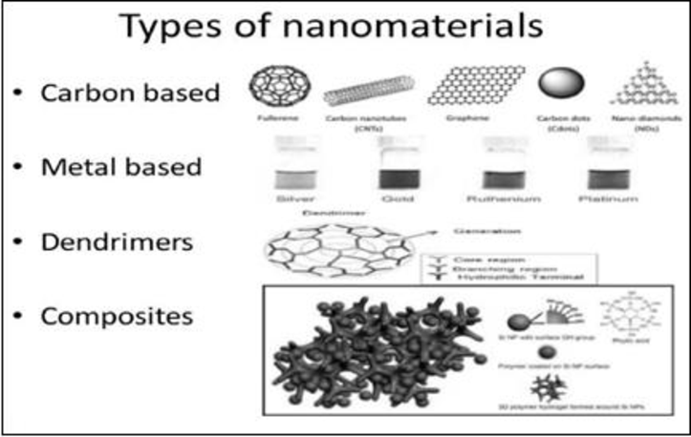

**Fig 1.1 types of nanomaterials** (Altammar, 2023).

1. **Carbon-based nanomaterials**: Include carbon nanotubes (CNTs), fullerenes, graphene, and carbon dots. These are lightweight and electrically conductive with diverse applications in nanomedicine and electronics.
2. **Inorganic-based nanomaterials**: Include metal nanoparticles (e.g., Au, Ag, Cu) and metal oxide nanoparticles (e.g., CuO, TiO₂, ZnO). These materials are extensively used in photocatalysis, antibacterial treatments, and sensing technologies (Ren et al., 2009).
3. **Polymeric nanomaterials**: Made from organic polymers, these are often used for drug delivery due to their biocompatibility and controlled release profiles.
4. **Composite nanomaterials**: Combine two or more materials to leverage synergistic properties. For instance, CuO/g-C₃N₄ composites exhibit enhanced photocatalytic activity and antibacterial performance due to improved charge separation and ROS generation under visible light (Wang et al., 2015)

**1.5.3 Unique Properties of Nanomaterials**

Nanomaterials possess unique properties that distinguish them from bulk materials due to their nanoscale dimensions and high surface-area-to-volume ratio. These properties include enhanced mechanical strength, tunable optical characteristics, altered electrical and magnetic behaviors, and modified thermal properties. At the nanoscale, mechanical properties such as hardness and toughness are significantly improved due to the increased number of surface atoms and interfaces, which also contribute to enhanced reactivity and catalysis (Baig et al., 2021). Nanomaterials exhibit distinct electrical behaviors, such as quantum confinement effects that allow for tuning electronic properties, making them ideal for applications in sensors, energy storage, and optoelectronics (Matsoukas et al., 2015). Their optical characteristics, like size-dependent fluorescence in quantum dots, are valuable in medical imaging and diagnostics (Altammar, 2023). Furthermore, their magnetic properties, such as superparamagnetism, and altered thermal conductivity, open up opportunities in applications like targeted drug delivery and nanoscale thermal management (Baig et al., 2021). These unique properties enable nanomaterials to have wide-ranging applications in fields such as medicine, environmental science, electronics, and energy (Altammar, 2023).

**1.5.4 Applications of Nanomaterial**

Nanomaterials have emerged as key enablers of advanced technologies due to their high surface area, tunable physicochemical properties, and quantum-scale behavior. Their unique features make them suitable for applications across a broad range of scientific and industrial domains.

**1.5.4.1 Environmental Applications**

Nanomaterials such as metal oxide nanoparticles (e.g., TiO₂, ZnO, CuO) and 2D materials like g-C₃N₄ are extensively used in photocatalysis for water and air purification. These materials help degrade organic pollutants and harmful dyes under sunlight or visible light by generating reactive oxygen species (ROS) (Wang et al., 2015). Hybrid nanomaterials like CuO/g-C₃N₄ enhance visible-light absorption and charge separation, leading to improved photocatalytic degradation efficiency.

**1.5.4.2 Biomedical and Antibacterial Applications**

Nanoparticles such as silver (AgNPs), zinc oxide (ZnO), and copper oxide (CuO) show broad-spectrum antimicrobial activity against bacteria, viruses, and fungi. They disrupt microbial membranes, produce ROS, and release toxic metal ions, making them effective for wound dressings, coatings, and disinfectants (Ren et al., 2009). Nanomaterials are also applied in drug delivery, bioimaging, and biosensing due to their high surface-to-volume ratio and ability to penetrate biological membranes (Khan et al., 2019).

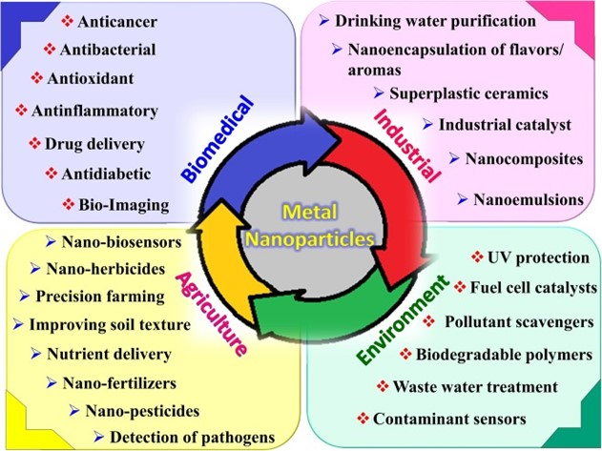

**Fig 1.2 Application of Nanomaterial** (Ren et al., 2009).

**1.6 Composite Materials**

Composite materials are engineered materials made by combining two or more constituent materials with significantly different physical or chemical properties. The resulting material exhibits properties superior to those of the individual components (Chawla, 2012). The constituents typically include a matrix and a reinforcement phase, where the matrix binds the reinforcement and transfers load between components, while the reinforcement imparts strength and stiffness.

In the realm of nanotechnology, nanocomposites represent a special class of composite materials in which one of the phases is in the nanoscale range (1–100 nm). These materials often show enhanced mechanical, thermal, electrical, and functional properties compared to conventional composites (Ajayan et al., 2003)

**1.7 BIOMATERIALS**

biomaterials are substances—natural or synthetic—that are engineered to interact with biological systems for medical purposes, such as diagnosis, therapy, repair, or replacement of tissue or organs (Ratner et al., 2013). These materials must exhibit biocompatibility, biofunctionality, and often biodegradability, depending on the specific application. Biomaterials can take the form of metals, polymers, ceramics, composites, or nanomaterials, and are increasingly tailored at the molecular or nanoscale level to meet specific performance criteria.

**1.7.1 Nontoxicity**

A designed biomaterial should serve its purpose in the environment of the living body without affecting other bodily organs. For that, a biomaterial should be nontoxic. Toxicity for biomaterials deals with the substances that migrate out of the biomaterials. In general, nontoxicity refers to noncarcinogenic, nonpyrogenic, nonallergenic, blood compatible, and noninflammatory of biomaterial. It is reasonable to say that a biomaterial should not give off anything from its mass unless it is specifically engineered to do so. In some cases, biomaterial is designed to release necessary amount of masses that is considered toxic. This toxicity of the designed biomaterials gives an advantage. Example a “smart bomb” drug delivery system that targets cancer cells and destroys them (Gilmore & Carson, 2015) Nanotoxicity refers to the potential toxic effects of nanomaterials on living organisms, cells, and ecosystems due to their unique physicochemical properties at the nanoscale. While nanomaterials offer significant advantages in various fields (e.g., biomedical, environmental, and industrial applications), their small size, high surface area, and reactivity may also pose health and environmental risks (Buzea et al., 2007).

**1.8 COPPER OXIDE NANOPARTICLE**

The elements copper and oxygen, which are found in blocks D and P of the periodic table, respectively, combine to form copper oxide. Four oxygen ions work together to coordinate the copper ion in a crystal. Since copper is one of the most essential elements in contemporary technologies and is easily accessible, copper (Cu) and copper oxide (Cu2 O) nanoparticles have garnered a lot of interest. Copper nanoparticles are becoming more and more popular because of their mechanical, electrical, optical, and catalytic qualities (A Brief Review on Synthesis and Characterization of Copper Oxide Nanoparticles and its Applications 2016) copper oxide (CuO) NPs have attracted researchers worldwide because of low cost, high-yielding material compared to silver, gold, and platinum oxide NPs. CuO is known as an environmentally friendly, nontoxic, magnetic p-type direct band gap semiconductor with an optical band gap energy of E*g* ∼ 1.2 eV. The band gap and magnetic properties can easily be tuned by applying the surface pressure through reducing the particle size. CuO nanoparticles (NPs) have been shown to be a potential candidate in varieties of applications such as bio/gas sensors, energy storage, heterogeneous catalysis, solar cells, photothermal application, electronics, environmental remediation, antimicrobial/bacterial, magnetic, and so on. The textile industry, thermosensing and conducting materials, gas sensors, catalysis, synthesis of inorganic–organic nano-sized composites, magneto-resistant materials, high-temperature superconductors, environmental remediation, and antibiotics are just a few of the many biological and non-biological uses for CuO NPs(Mishra et al. 2024)

**1.8.1 PROPERTIES OF COPPER OXIDE**

Transition metal oxides hold great promise as materials for photocatalysts in semiconductors. Due to its high abundance, low cost, non-toxic properties, excellent inherent thermal safety, and environmental friendliness, CuO is particularly significant. CuO has a narrow band gap between 1.2 and 1.5 eV, making it a p-type semiconductor. It has drawn a lot of interest due to its wide range of uses as a heterogeneous catalyst, gas sensor, and solar photovoltaics. Since they have a lower synthesis temperature, a simpler synthesis procedure, and a bigger specific area, amorphous metal oxides or metal sulfides are believed to be better to their crystalline counterparts. Furthermore, prior research has demonstrated that it has superior hole/electron mobility when compared to its crystalline equivalent, which includes amorphous MoSx, NiS, Co3O4, etc. In comparison to their crystalline form, amorphous materials are thought to have superior redox centers in bulk on their surface for extremely effective photocatalysis. Even while amorphous CuO has a slightly wider band gap than crystalline CuO, its better surface area and outstanding charge conductivity greatly aid photocatalytic activities (Zhao et al. 2021)

**1.9 Graphitic Carbon Nitride (g-C₃N₄)**

Graphitic materials, such as graphene or graphene oxide, are commonly added to CuO (copper (II) oxide) to enhance its photocatalytic performance in the degradation of organic dyes. This combination improves the overall efficiency through several synergistic effects. Firstly, CuO alone tends to suffer from the rapid recombination of photogenerated electron-hole pairs, which limits its photocatalytic activity. The addition of graphitic materials helps in effectively separating these charge carriers, as the graphitic structure can act as an electron acceptor and conductive pathway, facilitating faster electron transport and reducing recombination. Secondly, graphitic materials offer a high surface area, which increases the number of active sites available for dye adsorption and improves the interaction between the catalyst and dye molecules. Furthermore, these materials enhance light absorption, particularly in the visible range, allowing the composite to utilize a broader spectrum of light for photocatalysis. The formation of a heterojunction between CuO and the graphitic material also promotes more efficient charge separation and transfer. Overall, the incorporation of graphitic material into CuO leads to improved photocatalytic activity, resulting in faster and more effective degradation of organic dyes in wastewater treatment applications.

Typically an n-type semi-conductor with a medium bandgap energy of about 2.7 eV, graphitic carbon nitride (g-C3N4) can be utilized to break down contaminants such antiviral medications in pharmaceutical effluent when exposed to visible light. But g-C3N4 has a lower photocatalytic activity because of the rapid recombination of photoexcited charges. To solve this, a variety of methods have been investigated to increase g-C3N4's photocatalytic activity. Consequently, it has been shown that building the heterojunction of metal oxide/g-C3N4-based photocatalysts allows the photogenerated electrons and holes in the valence and conduction bands to move from one semiconductor to the valence and conduction bands of another semiconductor, respectively, making the light response range significantly wider. In recent years, g-C3N4 has been modified to enhance its optical, electrical, and photoelectrochemical capabilities using CuO (usually a p-type, bandgap = 1.2–1.9 eV)(Mamba et al. 2025)

A highly effective, stable, and reasonably priced photocatalyst that can capture visible light is said to be the most important component of cost-effective photocatalysis applications among the several kinds of semiconductors. According to this perspective, g-C3N4 has been regarded as a promising photocatalyst because of its low cost, environmental friendliness, intriguing electronic band topologies, and photochemical stability. Due to the potential benefits of its well-established fundamental physical features, g-C3N4 has rapidly garnered significant attention as a metal-free material. Because of its reasonable bandgap of 2.7 eV, appropriate conduction band (CB) of 1.3 eV, and valance band (VB) of 1.4 eV, g-C3N4 is very encouraged to absorb some visible light. Additionally, gC3N4 has a structural arrangement like graphene and is made up of highly abundant earth elements (carbon and nitrogen), which lowers synthesis costs and offers excellent physicochemical stability. As observed in many other photocatalysts, the pristine g-C3N4 exhibits drawbacks such as limited charge carrier mobility and fast recombination of photoexcited electron-hole pairs, despite its strong photoresponse to visible light and excellent thermal and chemical stabilities. Therefore, in order to satisfy the demands of a larger range of applications, g-C3N4's photocatalytic effectiveness must be further increased. In order to do this, many modification techniques have been studied, such as the structure and morphology of the basal engineering the semiconductor composite of hybrid engineering, co-catalyst loading, element flaws, and element doping (V, D, and S 2018)

**1.10 PHOTOCATALYTIC ACTIVITY**

Using semiconductors for photocatalytic wastewater treatment is one of the well-known techniques for eliminating organic pollutants. A metal-free semiconductor, g-C3N4, and g-C3N4-based nanocomposite have been widely utilized in many different applications in recent years due to their excellent electrical and optical qualities as well as their superior chemical and thermal strength (Chellakannu et al. 2024)

Pollutants in wastewater with high concentrations could be swiftly removed by coagulation, precipitation, and adsorption. These methods are ineffective for low concentrations, though, particularly in complex situations. organic pollutants can be broken down into less harmful molecules, such as CO2 and H2O, using a straightforward process called photocatalytic elimination (Chen et al. 2020)

One method that shows promise for turning dangerous dyes into innocuous molecules is the semiconductor photocatalytic system, which is renowned for being ecologically beneficial. Choosing the right semiconductor material is the most crucial part of photocatalysis (Vignesh et al. 2024)

Photocatalysts possess antibacterial qualities and the ability to produce hydrogen through water splitting. Separating and gathering these components from purified water is one of the most difficult aspects of employing photocatalysts for water purification. Toxic and polluting substances are converted into less hazardous substances like CO2 and H2O with the use of photocatalysts. Water treatment using semiconductor-based photocatalysts is an economical, high-efficiency, and eco-friendly option. In addition to their antibacterial properties, photocatalysts may split water to generate hydrogen. Extracting and gathering these components from cleaned water is one of the more difficult parts of using photocatalysts for water purification (Ajami, Sheibani, and Ataie 2024)

Energy conversion and environmental cleanup are two major problems that photocatalytic technology may offer a fresh approach to, both of which enhance the earth's resilience and sustainability. Appropriate photocatalysts can directly use sunlight to produce hydrogen, break down pollutants, and lower CO2 because of its environmental benefits. Designing a photocatalyst with high efficiency, observable light response activity, environmental friendliness, and good stability is therefore worthwhile. Although there have been some advancements in semiconductor photocatalyst research recently, there are still certain issues that need to be resolved immediately (Aslam et al. 2024)

**1.11 SEMICONDUCTOR PHOTOCATALYSIS**

Semiconductor photocatalysis involves the use of semiconductor materials to promote chemical reactions under light irradiation, typically utilizing ultraviolet (UV) or visible light. The process is based on the ability of semiconductor materials to absorb light and generate electron-hole pairs, which can drive chemical reactions on their surface, such as the degradation of pollutants or the splitting of water for hydrogen production.Semiconductors such as TiO₂, ZnO, and CuO are commonly employed in photocatalytic processes. These materials have bandgap energies that allow them to absorb light and generate photoexcited charge carriers (electrons and holes), which are essential for initiating photocatalytic reactions (Hoffmann et al., 1995).

**1.11.1 Mechanism of Photocatalytic Reactions**

The photocatalytic process typically follows these steps:

**Light absorption**: When a semiconductor is exposed to light with energy greater than its bandgap, electrons from the valence band (VB) are excited to the conduction band (CB), creating electron-hole pairs.

**Charge separation**: The photogenerated electrons (e⁻) and holes (h⁺) can then migrate to the surface of the semiconductor, where they participate in redox reactions.

**Redox reactions**: On the surface of the semiconductor, electrons can reduce adsorbed species, such as oxygen (O₂), to generate reactive oxygen species (ROS), while holes can oxidize water molecules to produce hydroxyl radicals (OH•). These reactive species are highly effective in degrading organic pollutants, disinfecting bacteria, or splitting water for hydrogen production (Zhao et al., 2016).

**Recombination**: In the absence of efficient charge separation, the electron-hole pairs can recombine before they participate in a photocatalytic reaction, leading to inefficiencies in the process. Therefore, nanostructuring the material or coupling semiconductors (e.g., CuO/g-C₃N₄ composites) can improve charge separation and overall photocatalytic efficiency (Zhang et al., 2014).

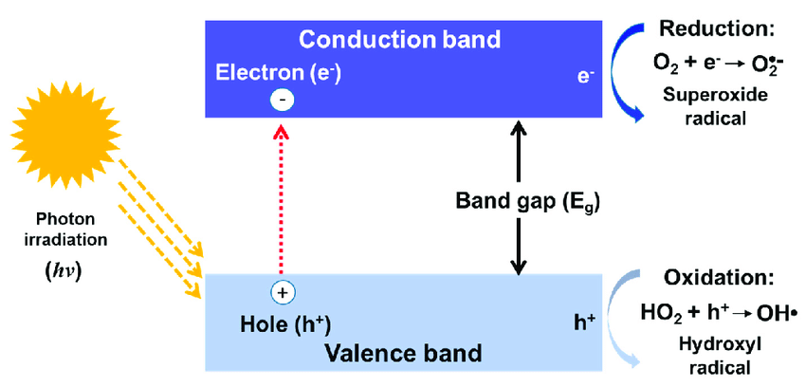

**Fig.1.3. Basic Principle of Photocatalysis** (Chen et al. 2020)

**1.11.2 Photocatalytic Degradation**

Photocatalytic methods that employ heterostructured materials, like g-C3N4/CuO, continue to be very successful in degrading dyes when exposed to visible light. Numerous characteristics of graphitic carbon nitride (g-C3N4), including its two-dimensional (2D) nanostructure, narrow band gap energy (2.7 eV), excellent charge separation, and good chemical stability, have drawn a lot of interest in study. Graphitic carbon nitride assisted photocatalysis is gaining popularity because of its low cost, excellent durability, and nontoxicity. CuO has attracted a lot of attention because of its great catalytic performance, wealth of resources, environmental commitment, and economic viability. The photocatalytic degradation performance of different organic pollutants has been studied in recent years using materials based on g-C3N4, such as CuO/NiO . The photocatalytic activity of the produced materials was also examined by subjecting MB aqueous to visible light. The photocatalytic activity of the g-C3N4/CuO nanocomposite is higher than that of two pure g-C3N4 and CuO samples. The enhancement of photocatalytic performance was thoroughly investigated in order to have a better understanding of the optical response mechanism. All of these factors work together to improve CuO/g-C3N4 photocatalysts, providing workable environmental cleanup solutions while overcoming the drawbacks of current techniques (Muthuganesh et al. 2025) .It is challenging to effectively remove persistent organic pollutants (POPs) in a short amount of time. To far, a wide range of treatment methods have been used to remove dangerous pollutants from soils, rivers, and wastewater, including biodegradation, (photo)catalytic degradation, adsorption, coagulation, precipitation, and reduction. Amongst these processes, coagulation, adsorption, photocatalytic degradation, and biodegradation are effective ways to get rid of organic contaminants (Chen et al. 2020)

**1.12 CHARACTERTIZATION**

Due to their unique physicochemical characteristics, including a large specific surface area, a moderate energy gap (~2.7 eV), superior electronic properties, an abundance of functional groups, and surface defects, graphitic carbon nitride (g-C3N4) nanomaterials have gradually drawn interest from a variety of disciplinary fields. These characteristics result in high adsorption capacity for the binding of metal ions and organic molecules, great chemical stability, and good absorption of visible light for photocatalytic reactions.[8] creating efficient and quick methods for purifying aquatic habitats is essential. Because of its remarkable physio-chemical characteristics and stability, graphitic carbon nitride (g-C3N4, GCN) has attracted a lot of interest in a variety of sectors, including solar-fuel conversion, photocatalysis, water splitting, sensors, etc. Unfortunately, pure g-C3N4's small surface area, reduced quantum efficiency, and propensity for significant recombination of photo-produced carriers have limited its practical use due to its poor light-absorbing capabilities. The structural, morphological, and optical characteristics of the provided composite sample were thoroughly examined using XRD, FT-IR, FE-SEM, TEM, UV-Vis DRS, and PL spectroscopy. Furthermore, by breaking down the toxic crystal violet (CV) dye under VL exposure, the catalysts' photocatalytic potential was assessed (Vignesh et al. 2024)

**Chapter 2**

**Review of literature**

**2.1. CuO/g-C₃N₄ composites for degradation of organic pollutants**

Li, H., et al. (2021), have been studied focused on the synthesis of CuO/g-C₃N₄ composites using a simple impregnation method. The resulting composites demonstrated enhanced photocatalytic degradation of tetracycline (94% degradation) under visible light. The study attributes the enhanced performance to the effective charge separation, increased surface area, and synergistic interaction between CuO and g-C₃N₄. Moreover, the antibacterial activity against *E. coli* and *S. aureus* was also significant, attributed to the generation of reactive oxygen species (ROS) during the photocatalysis process. The CuO component was key in the photocatalytic disinfection mechanism.

**2.2. Photocatalytic properties and antibacterial activity of CuO/g-C₃N₄ composites**

Sharma, A., et al. (2022), have been reported and the authors examined CuO/g-C₃N₄ composites' ability to degrade organic pollutants like methylene blueand rhodamine B. Their results show that the composites exhibited significantly higher degradation efficiencies under visible light when compared to individual CuO or g-C₃N₄. They also investigated the antibacterial properties, where the composite demonstrated substantial bacterial inactivation against *E. coli* and *S. aureus*. The study links the ROS generation as the primary mechanism for bacterial membrane damage and microbial inactivation.

**2.3. Design of Type-II and Z-Scheme Heterojunctions in CuO/g-C₃N₄ composites**

Wang, Z., et al. (2022) have been studied and presents an in-depth examination of the synthesis of CuO/g-C₃N₄ heterojunctions using various techniques such as hydrothermal and co-precipitation methods. The paper focuses on the formation of type-II and Z-scheme heterojunctions, which are crucial in enhancing the photocatalytic efficiency by improving charge carrier separation and reducing electron-hole recombination. The CuO/g-C₃N₄ composites exhibited efficient degradation of organic dyes like methylene blue under visible light, and this performance was attributed to the enhanced electron transfer at the heterojunction interface.

**2.4. Photocatalytic performance and stability of CuO/g-C₃N₄ composites**

Jiang, Z., et al. (2023) have been explored the photocatalytic performance of CuO/g-C₃N₄ composites in the degradation of antibiotic contaminants such as tetracycline and phenol. The authors highlight the enhanced degradation efficiency of CuO/g-C₃N₄ composites compared to pure CuO or g-C₃N₄. Characterization techniques confirmed the efficient charge separation and high surface area of the composite, which contribute to its superior photocatalytic activity. The paper also emphasizes the high stability and reusability of the composites, making them promising candidates for long-term environmental applications.

**2.5. Photocatalytic degradation and antibacterial performance**

Zhang, Y., et al. (2023) have been reported the Photocatalytic degradation and antibacterial performance of CuO/g-C₃N₄ composites investigate the potential of CuO/g-C₃N₄ composites for photocatalytic degradation of organic pollutants and their antibacterial properties.The study highlights that the CuO/g-C₃N₄ composites are highly effective in the degradation of dye pollutants like rhodamine B and methylene blue, demonstrating a significant improvement in photocatalytic efficiency compared to pure CuO and g-C₃N₄. Additionally, the composites show strong antibacterial activity against E. coli and S. aureus, with ROS generation being the primary mechanism for microbial inactivation.

**2.6. Synthesis and characterization of CuO/g-C₃N₄ composites**

Jiang, H., et al. (2023) -have been presented and delves into the synthesis of CuO/g-C₃N₄ composites through hydrothermal and co-precipitation methods, highlighting the influence of synthesis parameters on the morphology, structure, and photocatalytic performance of the composites. The results suggest that the CuO/g-C₃N₄ composites exhibit enhanced photocatalytic activity due to the formation of heterojunctions, which promote efficient charge transfer. The study also discusses the potential of these composites for real-world water treatment applications, considering their high degradation efficiency and stability under light irradiation.

**CHAPTER 3**

**MATERIALS AND METHEODS**

**3.1 SYNTHESIS OF CUO/g-C3N4 NANOCOMPOSITE**

The CuO/g-C₃N₄ nanocomposite was synthesized using a simple precipitation method. Initially, 2.5 g of g-C₃N₄ was dispersed in 100 mL of distilled water and sonicated for 15 minutes to achieve uniform dispersion. To this suspension, 1 g of polyvinylpyrrolidone (PVP) was added as a stabilizing agent, followed by 4 g of copper acetate, which serves as the copper source. Then, 3 mL of glacial acetic acid was introduced to maintain a suitable pH and promote complex formation. Finally, 4 g of sodium hydroxide (NaOH) pellets were slowly added under continuous stirring, leading to the precipitation of copper hydroxide, which subsequently converted to CuO nanoparticles. These CuO particles anchored onto the g-C₃N₄ surface, forming a stable CuO/g-C₃N₄ nanocomposite suitable for antibacterial and organic degradation applications.

2.5g g-C3N4 in 100ml distilled water

(sonication for 15mins)

1g of polyvinylpyrrolidone (PVP)

4g copper acetate

3ml glacial acetate

4g NaOH pellet is added

**3.2 X-RAY DIFFRACTION**

X-ray diffraction is an effective technique for both detailed structural elucidation and material characterization. Determining the crystal structure is an essential component of the structural and chemical characterisation of materials since the atomic arrangements of the materials determine the physical properties of the solid (such as electrical, optical, magnetic, etc.). Because the lattice parameter, d (spacing between various planes), is of the order of X-ray wavelength, X-ray patterns are utilized to determine the atomic arrangements of the materials. Additionally, the X-ray diffraction method can be used to differentiate between crystalline and nanocrystalline (amorphous) materials. The X-ray diffraction pattern analysis is used to identify the structure, and it is compared to the globally accepted database that contains the reference pattern (JCPDS).   
The X-ray diffraction pattern provides the following details:

1. To assess the data of a certain material system,

2. Miller indices, unit cell structure, and lattice parameters

3. The different stages found in the substance,

4. The estimation of the sample's crystalline and amorphous components   
5. Calculating the average crystalline size in a given phase pattern based on peak width. Peak width increases with decreasing crystal size, whereas sharp peaks are produced by large crystal size.

6. A review of the structural distortion that results from the strain-induced change in d-spacing, or thermal distortion.

**3.2.1 DETERMINATION OF CRYSTAL SIZE:**

The most widely used technique for estimating the size of crystallites in nanomaterials is X-ray diffraction analysis, which has been widely applied in this work. Careful analytical abilities are necessary for evaluating crystalline sizes in the nanoscale range. The growth of the internal stain and crystalline refinement is responsible for the Bragg peaks' broadening. The full width at half maximum (FWHM) of the Bragg peaks as a function of the diffraction angle is examined in relation to size widening and stain broadening. The materials' crystallite size is determined by the peak broadening of X-ray diffraction (XRD). Cu Kα radiation is used to obtain the diffraction patterns at a scan rate of 1°/min. Using pseudo-Voigt curve fitting, the full width half maxima (FWHM) of the diffraction peaks were determined.

D = 0.9λ/ βcosθ

Grain size can be determined using the Scherrer equation after subtracting the instrumental line broadening, which was measured using silicon and quartz standards. The X-ray wave length is represented by λ, the peak angle by θ, and the FWHM in radians by β.

**3.2.2 DETERMINATION OF LATTICE PARAMETERS**

Through the Miller indices hkl, the interplaner distance (d) of the {hkl} plane for the Wurtzite structure is connected to the lattice parameters a and c:

(4/3 (h2 + k2 + hk/a2) + l2/c2 = (1/dhkl)2

Thus, the interplanar distance (d) and hkl value can be used to compute the lattice parameters.

**3.2.3 SAMPLE PREPARATION**

Room temperature CuO nanopowder was subjected to X-ray diffraction examination. Using a scanning speed of 0.02/sec and a tiny 0.1mm slit, the diffractogram was recorded. A 10 mm-diameter aluminum holder was used to securely press the sample. The diffraction patterns were acquired at a scan step duration of 10.3356 (s) over the 2θ value in the range of 20˚ to 80˚. It is estimated that the lattice parameter inaccuracy is around 0.005A°. The JCPDS database's patterns and the experimental pattern were contrasted.

This study used a PRO diffractometer to record the X-ray diffraction (XRD) patterns of a few chosen materials. Using CuKα radiation (λ= 1.54060 A°), the samples were recorded at room temperature. The operating voltage and current of the X-ray tube were 40 Kv and 30mA, respectively. The XRD studies were carried out from satyabama University, chennai, Tamil Nadu.

**3.3 X-ray Photoelectron Spectroscopy (XPS)**

The synthesised nanocomposite materials' surface elemental composition, oxidation states, and chemical environments were examined using X-ray Photoelectron Spectroscopy (XPS). When assessing surface chemistry, which has a major impact on the catalytic, electrical, and antibacterial qualities of nanomaterials, this method is essential. The Sathyabama Institute of Science and Technology in Chennai, Tamil Nadu, is where the XPS measurements were carried out.

X-ray Photoelectron Spectroscopy (XPS) was employed to investigate the surface elemental composition and chemical states of the synthesized CuO/g-C₃N₄ composites. The measurements were carried out using a [Insert Instrument Name and Model, e.g., Thermo Scientific K-Alpha+ XPS system] equipped with a monochromatic Al Kα radiation source (hν = 1486.6 eV). The base pressure during analysis was maintained below 1 × 10⁻⁹ mbar.

Samples were prepared by depositing finely ground powder onto double-sided carbon tape mounted on the XPS sample holder. Prior to analysis, the samples were outgassed under vacuum to remove surface contaminants.

The survey scans were recorded in the binding energy range of 0–1100 eV to identify all elements present, using a pass energy of 150 eV. High-resolution spectra for Cu 2p, O 1s, C 1s, and N 1s were recorded at a pass energy of 20 eV to determine the chemical states of each element. The binding energy scale was calibrated using the C 1s peak at 284.6 eV (adventitious carbon) as the reference.

Data processing and peak deconvolution were performed using [Insert Software Name, e.g., CasaXPS or Avantage], employing a Shirley background and Gaussian–Lorentzian peak fitting method. Quantification was carried out based on the relative sensitivity factors (RSFs) provided by the instrument software.This analysis provided essential insights into the oxidation states and surface chemistry of the CuO/g-C₃N₄ composite, which are critical for understanding its photocatalytic and antibacterial performance.

**3.4 FE-SEM AND XRD**

Field Emission Scanning Electron Microscopy (FESEM) was utilized to investigate the surface morphology and nano structural characteristics of the synthesized CuO/g-C₃N₄ composites. This characterization was crucial for evaluating the dispersion of CuO nanoparticles on the g-C₃N₄ matrix, which directly influences the material's performance in antibacterial and photocatalytic applications.

The samples were analysed using a high-resolution FESEM instrument (Model: FEI Nova Nano SEM 450) operated under high vacuum at an accelerating voltage ranging from 5 to 15 kV. Prior to analysis, the powdered samples were carefully mounted on aluminum stubs with conductive carbon tape and sputter-coated with a thin layer of gold to minimize charging effects and enhance image resolution.

FESEM images were obtained at various magnifications to observe the morphology of pure g-C₃N₄, CuO nanoparticles, and the CuO/g-C₃N₄ composite. Particular attention was given to the surface texture, agglomeration behavior, and the distribution of CuO particles within the composite structure. The uniform dispersion of CuO on g-C₃N₄ was considered critical for achieving optimal surface area and interface contact, enhancing both photocatalytic degradation and antibacterial efficiency.

Additionally, Energy Dispersive X-ray (EDX) analysis was performed alongside FESEM to confirm the elemental composition and distribution of Cu, O, C, and N in the nanocomposite. Elemental mapping validated the homogeneous dispersion of CuO nanoparticles, supporting the successful formation of the composite and its intended functional behavior.

This morphological and compositional analysis laid the foundation for understanding the structure–function relationship of the CuO/g-C₃N₄ composite in environmental and biological performance contexts.

**3.4.1 Instrument Details**

* Instrument: Field Emission Scanning Electron Microscope (FESEM)
* Model: Carl Zeiss Sigma (or comparable)
* Operating Mode: High Vacuum
* Working Distance: 8–10 mm
* Accelerating Voltage: 5–15 kV
* Magnification Range: ×50 to ×100,000
* Detectors Used:
* In-lens Secondary Electron Detector (SE)
* Backscattered Electron Detector (BSE)
* Silicon Drift Detector (SDD) for EDS analysis
* EDS Resolution: < 129 eV at Mn Kα

**3.4.2 Methodology:**

Field Emission Scanning Electron Microscopy (FESEM) was performed using a Carl Zeiss Sigma instrument (or a comparable model) operated in high vacuum mode. Imaging was conducted at an accelerating voltage between 5–15 kV with a working distance of 8–10 mm. The surface morphology and structural features of the CuO/g-C₃N₄ composites were examined at various magnifications, ranging from ×50 to ×100,000, to assess particle size, distribution, and surface texture.

For elemental analysis, the FESEM system was coupled with an Energy Dispersive X-ray Spectroscopy (EDS) detector based on a Silicon Drift Detector (SDD), offering a resolution of <129 eV at Mn Kα. EDS spectra were recorded to confirm the elemental composition, particularly the presence of Cu, O, C, and N. Additionally, elemental mapping was carried out to evaluate the spatial distribution and uniformity of CuO nanoparticles on the g-C₃N₄ matrix, which is critical for understanding the composite’s photocatalytic and antibacterial performance.

**3.4.3 SAMPLE PREPARATION**

* The synthesized CuO/g-C₃N₄ composite powders were dried thoroughly to eliminate any residual moisture that could affect imaging or analysis.
* A small quantity of the dried composite was placed on carbon adhesive tape affixed to an aluminum stub to ensure firm attachment during analysis.
* The sample was gently pressed and spread evenly to achieve a uniform surface suitable for high-resolution imaging.
* A thin layer of gold was sputter-coated onto the sample to enhance surface conductivity and prevent charging effects under the electron beam.
* The prepared samples were stored in a desiccator to prevent contamination and maintain stability prior to FESEM and EDS examination.

**3.4.4 ANALYTICAL PROCEDURE**

**FESEM Imaging**:

* Samples were loaded into the FESEM chamber under high vacuum conditions.
* Imaging was conducted at 5–15 kV accelerating voltage and 8–10 mm working distance.
* Magnifications ranging from ×50 to ×100,000 were used to analyze surface morphology and particle distribution.
* Observations were made to examine the uniformity of CuO nanoparticles on the g-C₃N₄ matrix.
* EDS Elemental Analysis:
* Energy dispersive X-ray spectra were collected to determine the elemental composition (Cu, O, C, N).
* Elemental mapping was performed to assess the distribution and uniformity of CuO in the composite.
* Data were analysed to correlate the structure with antibacterial and photocatalytic performance.

**3.5 Antibacterial Assay**

**3.5.1 Disc Preparation**

The 6mm (diameter) discs were prepared from Whatmann No. 1 filter paper. The discs were sterilized by autoclave at 121°C.After the sterilization the moisture discs were dried on hot air oven at 50°C.Then various solvent extract such as Acetone, Methanol, Ethanol discs and control discs were prepared.

**3.5.2 Collection of test bacteria**

The Bacterial strains of *K. pneumonia, E. Coli, B. Subtilis,* and *S. aureus* were obtained from Microbial Type culture Collection Centre (MTCC), Chandigarh.

**3.5.3 Assay of Antibacterial Activity**

Antibacterial activity test was carried out following the modification of the method originally described by Bauer *et al.,* (1966). Muller Hinton agar was prepared and autoclaved at 15 lbs pressure for 20 minutes and cooled to 45ºC. The cooled media was poured on to sterile petriplates and allowed for solidification. The plates with media were seeded with the respective microbial suspension using sterile swab. The various solvents such as Acetone, Methanol, Ethanol extracts discs were prepared and individually placed on the each petriplates also placed control and standard Nitrofurantoin (300 µg) for Bacteria discs. The plates were incubated at 37ºC for 24 hrs. After incubation period, the diameter of the zone formed around the paper disc were measured and expressed in mm.

**3.6 Photocatalytic activity**

The degradation of a model organic dye under visible light irradiation was used to examine the photocatalytic performance of the pure cuo and cuo/g-C₃N₄ nanocomposite. The study was carried out in the Environmental Nanotechnology Laboratory, Sathyabama Institute of Science and Technology, Chennai, Tamil Nadu.

**3.6.1 Photocatalytic Organic Degradation**

The photocatalytic degradation of organic pollutants, such as dyes and industrial waste, is a key application of CuO/g-C₃N₄ composites. Organic pollutants are often harmful to the environment and human health, and their degradation is essential for wastewater treatment and environmental cleanup.

Mechanism of Photocatalysis: Under UV or visible light irradiation, the CuO/g-C₃N₄ composite absorbs light energy, which excites electrons in the conduction band of g-C₃N₄. These electrons transfer to CuO, where they generate reactive oxygen species (ROS), such as hydroxyl radicals (•OH) and superoxide anions (O₂•⁻). These ROS can then degrade organic pollutants in the solution, breaking down complex molecules into simpler, non-toxic compounds.

Model Pollutants for Testing: Common model pollutants used for testing include methyl orange, rhodamine B, and phenol. The degradation process is typically monitored by measuring the change in the absorbance of the dye solution using UV-Vis spectroscopy, which correlates with the degradation of the pollutant over time.

Effect of Composite Structure: The photocatalytic performance of CuO/g-C₃N₄ composites is influenced by factors such as the morphology, surface area, and band gap of the composite. CuO’s ability to absorb visible light and g-C₃N₄’s ability to efficiently separate charge carriers significantly enhance the overall degradation efficiency.

**3.6.2 Analysis of Degradation Efficiency**

* UV-Vis Absorption Spectroscopy: The decrease in absorbance of the pollutants was monitored using a UV-Vis spectrophotometer (Shimadzu UV-2600).
* Degradation Efficiency Calculation:  
  The degradation efficiency was calculated using the following equation:
* Degradation Efficiency(%) =  ((C0 - C) / C0) * 100
* Where C0 is the initial concentration of the substance being degraded and C is the concentration after a certain time or treatment.

**3.6.3 Reusability and Stability Tests**

* Recycling of Catalyst: After each photocatalytic degradation cycle, the catalyst was separated by filtration, washed with deionized water, and dried.
* Reusability Testing: The catalyst was reused for several cycles, and the degradation efficiency was monitored.
* Characterization after Reuse: The reused catalyst was characterized using FESEM, XRD, and UV-Vis spectroscopy to assess changes in structure and performance.

**3.7 ANTICANCER ACTIVITY**

**3.7.1 Materials and Reagents**

* Cell line: HeLa (human cervical cancer cells)
* Culture medium: Dulbecco’s Modified Eagle Medium (DMEM)
* Supplements: 10% Fetal Bovine Serum (FBS), 1% Penicillin-Streptomycin
* Other reagents:
* Trypsin-EDTA solution
* MTT reagent (3-(4,5-dimethylthiazol-2-yl)-2,5-diphenyl tetrazolium bromide)
* Dimethyl sulfoxide (DMSO)
* Phosphate Buffered Saline (PBS)
* CuO/g-C₃N₄ nanocomposites (synthesized and characterized as described earlier)

**3.7.2 Cell Culture**

HeLa cells were maintained in DMEM supplemented with 10% FBS and 1% penicillin-streptomycin. The cells were incubated at 37°C in a humidified 5% CO₂ atmosphere. Sub-culturing was performed every 2–3 days using 0.25% trypsin-EDTA.

**3.7.3 Preparation of Nanocomposite Suspensions**

CuO/g-C₃N₄ nanocomposites were sterilized via UV exposure and dispersed in sterile PBS or culture medium. The suspension was sonicated for 20–30 minutes to ensure uniform dispersion. A range of concentrations (e.g., 5, 10, 25, 50, 100 µg/mL) was prepared for treatment.

**3.7.4 MTT Cytotoxicity Assay**

* The cytotoxic effect of CuO/g-C₃N₄ on HeLa cells was evaluated using the MTT assay:
* Cells were seeded in 96-well plates at a density of 5 × 10³ cells/well and allowed to adhere for 24 hours.
* Cells were treated with different concentrations of the nanocomposite and incubated for 24 and 48 hours.
* After the treatment period, 20 µL of MTT solution (5 mg/mL) was added to each well.
* The plates were incubated for 4 hours at 37°C.
* The resulting formazan crystals were dissolved by adding 100 µL of DMSO per well.
* Absorbance was measured at 570 nm using a microplate reader.

**3.7.5 Determination of IC₅₀ Value**

The IC₅₀ value, which represents the concentration of CuO/g-C₃N₄ nanocomposite required to inhibit 50% of HeLa cell viability, was determined based on the MTT cytotoxicity assay. After exposing HeLa cells to a range of nanocomposite concentrations for predetermined time intervals (typically 24 and 48 hours), absorbance values were measured to estimate cell viability.

Cell viability (%) was calculated using the following formula:

The percentage viability was then plotted against the corresponding concentrations of the nanocomposite. The dose-response curve was generated using GraphPad Prism software (or equivalent), applying a nonlinear regression model (sigmoidal dose-response curve with variable slope). The IC₅₀ value was estimated from this curve as the concentration at which 50% cell inhibition was achieved, serving as an indicator of the nanocomposite's anticancer potency.

**3.7.6 Statistical Analysis**

All experiments were conducted in triplicate. Data were expressed as mean ± standard deviation (SD). Statistical significance between control and treated groups was determined using one-way ANOVA, with *p* < 0.05 considered statistically significant.

**CHAPTER 4**

**RESULTS AND DISCUSSION**

**4.1 Synthesis of Cuo/g-C3N4 Nanocomposite**

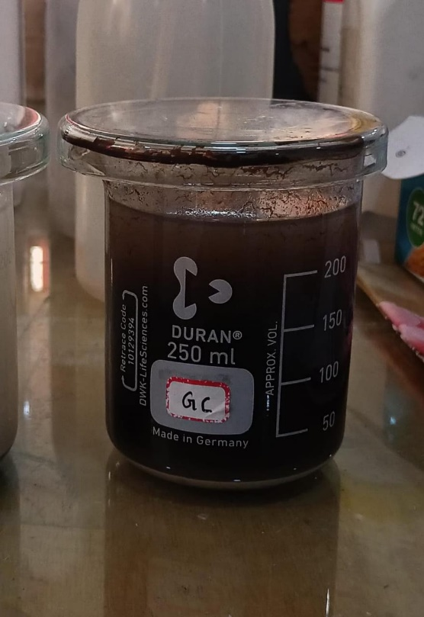

**Fig 4.1 Synthesized g-C3N4/CuO (GC) Composite Suspension**

The cuo/g-c₃n₄ nanocomposite was synthesized successfully via a co-precipitation method. initially, a turquoise-blue solution indicated the presence of copper(ii) ions. upon adding NaOH and heating to 120 °c, the color gradually changed to dark brown, confirming the formation of cuo nanoparticles.

g-c₃n₄, provided a high-surface-area support, while pvp acted as a stabilizer to ensure uniform dispersion of cuo. The color change and stable suspension visually indicated successful synthesis. the resulting composite is expected to exhibit enhanced photocatalytic properties due to the effective heterojunction between cuo and g-c₃n₄, which facilitates better charge separation and reduced recombination of photo-induced carriers.

**4.2 CHARACTERIZATION**

**4.2.1 energy-dispersive x-ray spectroscopy (eds)**

**Table 4.1 Elemental composition of CuO /g-C3N4 based on EDS analysis**

|  |  |  |  |  |
| --- | --- | --- | --- | --- |
| map sum spectrum | | | | |
| Element | Line type | Weight % | weight% sigma | Atomic% |
| c | k series | 34.69 | 0.29 | 42.51 |
| n | k series | 43.15 | 0.37 | 45.34 |
| o | k series | 10.19 | 0.21 | 9.38 |
| cu | k series | 11.97 | 0.13 | 2.77 |
| total |  | 100.00 |  | 100.00 |

the elemental composition and spatial distribution of the cuo/g-c₃n₄ nanocomposite were comprehensively examined through energy-dispersive x-ray spectroscopy (eds), providing both qualitative and quantitative insights into the successful synthesis of the composite material. the eds analysis, as shown in fig. 4.3, reveals the presence of four key elements—carbon (c), nitrogen (n), oxygen (o), and copper (cu)—corresponding to the graphitic carbon nitride matrix and the embedded cuo nanoparticles.

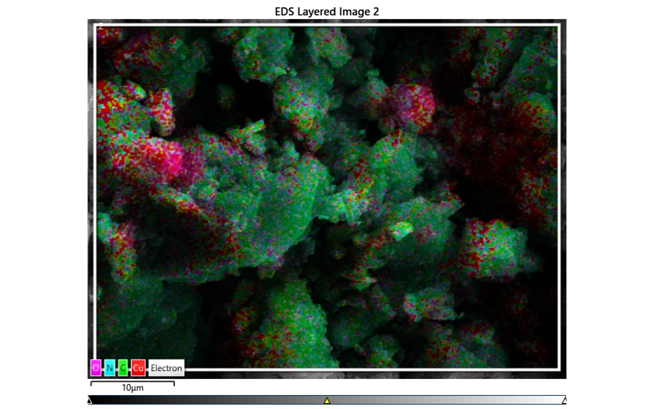

**Fig 4.2 EDS Spectrum of CuO/g-C₃N₄ Composite.**

In the EDS spectrum (Fig. 4.4), sharp peaks are detected at characteristic energy levels: C at ~0.27 keV, N at ~0.39 keV, and O at ~0.52 keV, which are representative of the g-C₃N₄ structure. These peaks confirm the high carbon and nitrogen content, a typical feature of polymeric g-C₃N₄, which consists of tri-s-triazine units interconnected by nitrogen bridges. The oxygen signal is attributed to the presence of oxygen-containing functional groups and, more prominently, to CuO species.

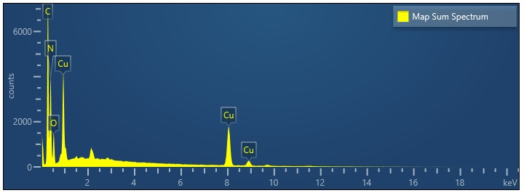

**Fig 4.3 EDS Elemental Mapping of CuO/g-C₃N₄ Composite**

Elemental distribution map showing uniform dispersion of Cu (orange), C (red), N (green), and O (blue) on the g-C₃N₄ matrix surface*.*Distinct copper peaks are observed around 0.93 keV (Lα), 8.05 keV (Kα), and 8.90 keV (Kβ), affirming the incorporation of copper in its oxidized form, likely as CuO nanoparticles. This confirms the chemical identity of the secondary phase and is consistent with the formation of copper oxide, which is known for its distinctive K-series X-ray emissions. The well-resolved copper peaks without interference or unexpected signals suggest high purity and minimal contamination in the final composite.

The quantitative elemental analysis (Table 1) further substantiates the material composition, with the following weight percentages: C (34.69%), N (43.15%), O (10.19%), and Cu (11.97%). The high nitrogen content indicates a stable g-C₃N₄ backbone, while the significant copper presence confirms a robust integration of CuO nanoparticles. The relatively balanced elemental distribution supports a homogenous composite structure, which is critical for uniform catalytic or antibacterial performance.

EDS elemental mapping (Fig. 4.3) provides spatial resolution of the element distribution within the composite. The grayscale SEM image in the background reveals a rough and porous surface morphology—typical for g-C₃N₄ and favorable for high surface area applications. Overlaid color maps identify copper (orange), carbon (red), nitrogen (green), and oxygen (blue). The copper-rich zones are well distributed over the matrix, indicating successful deposition of CuO nanoparticles onto the g-C₃N₄ layers. Carbon and nitrogen are uniformly dispersed, further confirming the preservation of the g-C₃N₄ framework post-synthesis. Oxygen appears in both the CuO and residual surface groups on g-C₃N₄, contributing to possible synergistic interactions.

The absence of additional peaks in the EDS spectrum rules out contamination or the presence of unintended elements, thereby confirming the chemical purity of the synthesized CuO/g-C₃N₄ nanocomposite. These findings are aligned with previous studies, such as the work by Cao et al. (2017), who reported a similarly uniform elemental distribution in metal oxide/g-C₃N₄ systems, validating the structural and compositional integrity of the composite material(Cao, Qin, Wang, B. Zhang, et al., 2017).

Moreover, the high dispersion of CuO nanoparticles is crucial for the intended antibacterial and photocatalytic applications of the composite. Uniform copper distribution ensures efficient interfacial contact with microorganisms or pollutants, enhancing reactive oxygen species (ROS) generation and thereby boosting antimicrobial efficacy and photocatalytic degradation. The porous structure observed through SEM supports enhanced surface adsorption and diffusion, which is further complemented by the catalytic activity of the CuO phase.

In conclusion, the EDS characterization offers strong evidence for the successful synthesis of a highly integrated and homogeneous CuO/g-C₃N₄ composite. The combination of C, N, O, and Cu in appropriate ratios, along with their uniform distribution, confirms the effective fabrication of the nanocomposite, validating its potential utility in applications such as antibacterial coatings, photocatalysis, and environmental remediation.

**4.2.2 Field Emission Scanning Electron Microscopy (FESEM)**

**Fig 4.4 FESEM image of pristine g-C₃N₄ displaying characteristic layered and wrinkled sheet-like morphology.**

**Fig4.5 FESEM image of CuO/g-C₃N₄ composite showing homogeneously distributed CuO nanoparticles on g-C₃N₄ sheets with increased surface roughness.**

Field Emission Scanning Electron Microscopy (FESEM) was employed to investigate the surface morphology and structural features of the synthesized CuO/g-C₃N₄ composite. The FESEM images, presented in Figures [X and Y], offer insights into the topography, texture, and particle distribution of the composite.

In **Figure 4.5**, the pristine g-C₃N₄ sample demonstrates a characteristic layered, sheet-like morphology, indicating its graphitic nature. The sheets are observed to be thin, with occasional folding and wrinkles, which is typical for thermally exfoliated g-C₃N₄. These morphological traits suggest a high surface area and abundant active sites, which are beneficial for photocatalytic and antibacterial applications.

**Figure 4.6,** depicting the CuO/g-C₃N₄ composite, reveals significant morphological changes post-synthesis. The image shows that the CuO nanoparticles are uniformly distributed over the g-C₃N₄ sheets. The CuO particles appear as spherical to semi-spherical clusters embedded onto or decorating the surface of the g-C₃N₄ nanosheets. The uniform dispersion and strong adherence of CuO nanoparticles indicate good interfacial contact between the two components, which is critical for efficient charge transfer during catalytic or antibacterial processes.

The incorporation of CuO into the g-C₃N₄ matrix has led to the creation of a more textured surface with increased roughness compared to pure g-C₃N₄. This morphological modification is advantageous as it can enhance the surface reaction kinetics by exposing more active sites and improving light absorption.

**4.2.3 X-ray diffraction (XRD)**

The corresponding XRD patterns of g-C₃N₄, pure cuo, and cuo/g-C₃N₄ nanocomposite are shown in Figures

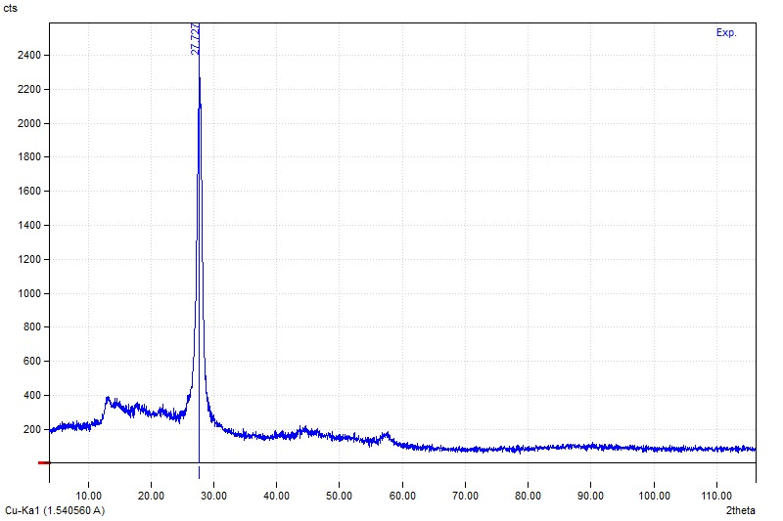

**Figure 4.6: XRD pattern of pristine g-C₃N₄.**

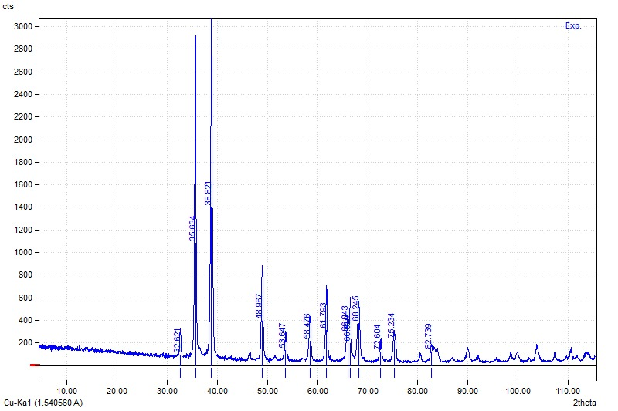

**Figure 4.7: XRD pattern of synthesized CuO nanoparticles**

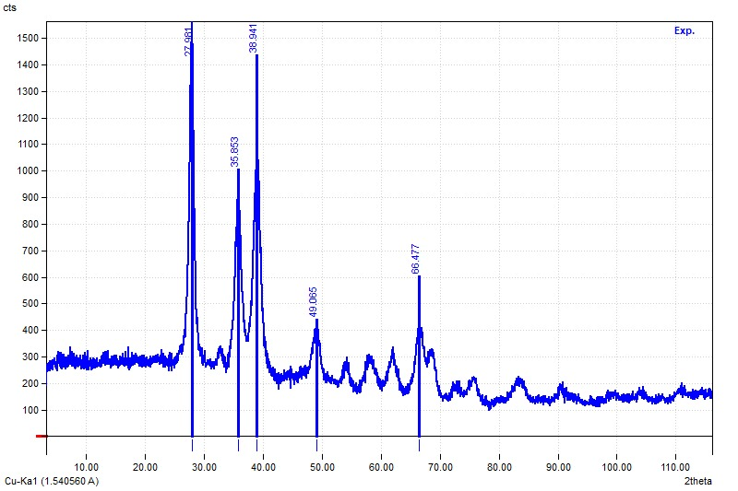

**Figure 4.8: XRD pattern of CuO/g-C₃N₄ composite**

The X-ray diffraction pattern of pure g-C₃N₄ (Figure t4) exhibits a dominant diffraction peak centered at 2θ ≈ 27.22°, which corresponds to the (002) plane of graphitic carbon nitride. This peak arises from the interlayer stacking of conjugated aromatic systems and confirms the layered, graphite-like structure of g-C₃N₄. The sharpness and intensity of the peak suggest a well-developed crystalline structure, although g-C₃N₄ is generally known to be semi-crystalline in nature. A smaller and broader shoulder around 13° is usually reported in literature and corresponds to the in-plane structural packing of tri-s-triazine units, though it may not be clearly visible in this sample due to its lower intensity or overlapping baseline noise. The observed XRD pattern aligns with standard reports, confirming the successful synthesis of g-C₃N₄ and its intact structural framework.

The XRD pattern of synthesized CuO (Figure t5) shows a series of sharp diffraction peaks at 2θ values of approximately 32.54°, 35.54°, 38.84°, 48.67°, 53.47°, 58.32°, 61.52°, 66.22°, 68.12°, 72.54°, and 75.24°, which are well indexed to the (110), (111), (200), (202), (020), (202), (113), (311), (220), (311), and (004) crystal planes of monoclinic CuO (JCPDS card no. 45-0937). These intense and narrow peaks indicate high crystallinity and phase purity of the CuO sample. The absence of additional peaks suggests that no impurity phases such as Cu₂O or Cu were present in the sample. This XRD profile confirms the successful synthesis of monoclinic CuO, consistent with earlier literature findings on thermally or hydrothermally derived CuO nanomaterials.

**4.2.3.1 XRD Pattern of CuO/g-C₃N₄ Composite:**

The XRD pattern of the CuO/g-C₃N₄ composite (Figure t6) reveals the coexistence of characteristic peaks from both g-C₃N₄ and CuO, indicating successful formation of the composite without significant structural decomposition. The broad peak at 2θ ≈ 27.64° corresponds to the (002) plane of g-C₃N₄, albeit with reduced intensity and slight broadening compared to the pure g-C₃N₄ sample, suggesting partial exfoliation or structural disruption due to CuO incorporation. Additionally, prominent CuO peaks are observed at 35.63°, 38.94°, 49.05°, and 66.47°, which align with its monoclinic phase. The presence of both sets of peaks in the XRD spectrum confirms that the composite retains the structural characteristics of both constituents. The shift and broadening of peaks imply strong interfacial interaction and good dispersion of CuO over the g-C₃N₄ matrix, which is crucial for enhancing photocatalytic or antibacterial activity. These results are in line with previously reported CuO/g-C₃N₄ systems, indicating a successful hybrid formation.

**4.2.4 X-RAY PHOTOELECTRON SPECTROSCOPY (XPS)**

The XPS survey spectrum (Fig.4.10 confirms the presence of Cu, O, C, and N elements in the CuO/g-C₃N₄ composite. The detection of Cu 2p, O 1s, and C 1s peaks affirms the successful incorporation of CuO onto the g-C₃N₄ matrix, while the nitrogen peak reflects the g-C₃N₄ framework



. 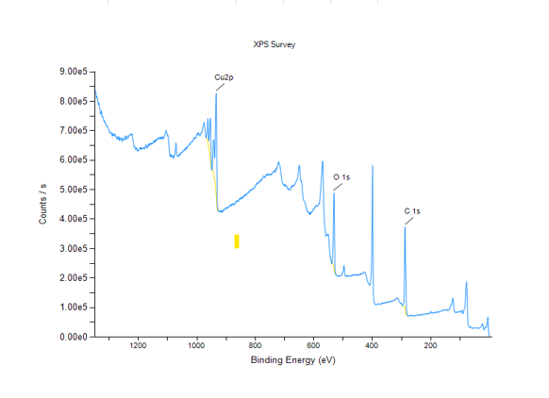

**Figure4.9. XPS survey spectrum of the CuO/g-C₃N₄ composite**

The high-resolution XPS spectrum of **Cu 2p** (Fig. 4.11) displays two distinct peaks at 933.6 eV and 953.4 eV, corresponding to Cu 2p₃/₂ and Cu 2p₁/₂, respectively. The energy separation of approximately 19.8 eV between these two peaks is characteristic of the Cu²⁺ oxidation state. Furthermore, the presence of satellite peaks around 943.7 eV and 962.1 eV provides additional evidence for the presence of CuO, consistent with previous reports (Biesinger et al., 2010; Gao et al., 2018).

The **O 1s** high-resolution spectrum (4.12) can be deconvoluted into three peaks at 529.8 eV, 531.1 eV, and 532.2 eV. The peak at 529.8 eV is attributed to lattice oxygen in CuO, while the peak at 531.1 eV is associated with surface-adsorbed oxygen species such as hydroxyl groups. The third peak at 532.2 Ev can be linked to adsorbed water or carbonates (Wang et al., 2020).

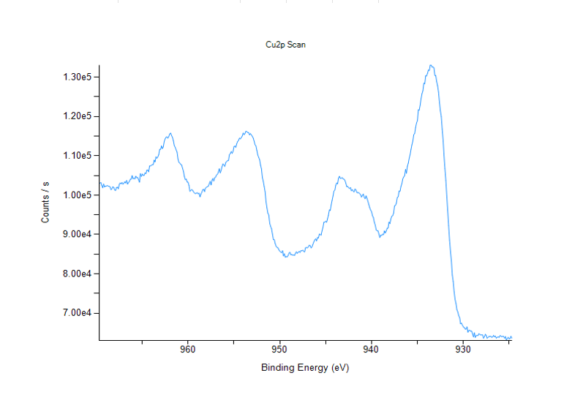

**Fig. 4.10 Cu 2p XPS Spectrum of CuO/g-C₃N₄ Nanocomposite**

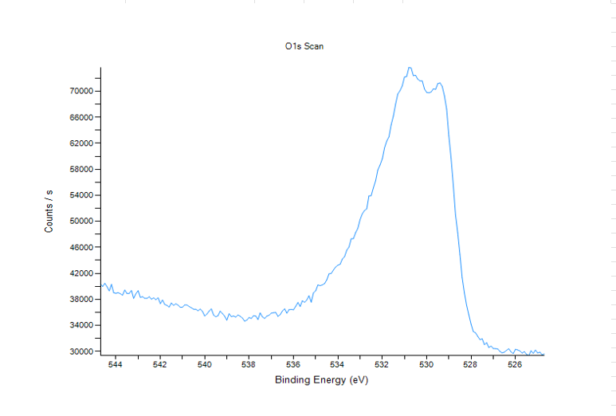

**Fig. 4.11 O 1s XPS Spectrum of CuO/g-C₃N₄ Nanocomposite**

The **C 1s** spectrum (Fig. 4.13) reveals three peaks located at 284.6 eV, 286.1 eV, and 288.2 eV. The peak at 284.6 eV corresponds to sp²-hybridized C–C bonds, typically associated with adventitious carbon. The peak at 286.1 eV is attributed to C–N bonding, while the 288.2 eV peak is ascribed to sp²-hybridized carbon in N–C=N configurations, confirming the graphitic character of g-C₃N₄ (Li et al., 2021; Zheng et al., 2019).

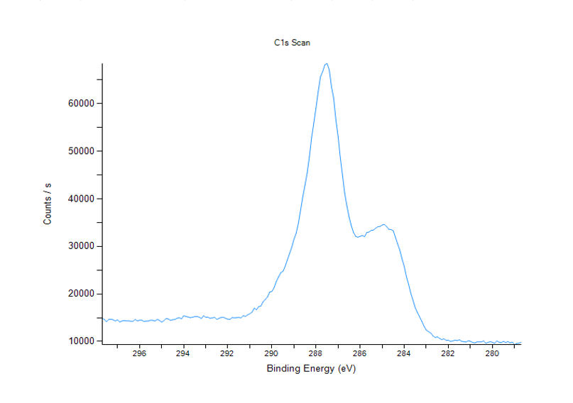

**Fig.4.12: C 1s XPS Spectrum of CuO Nanoparticles**

Overall, the XPS analysis supports the successful formation of the CuO/g-C₃N₄ heterostructure. The slight shift in binding energies and the identification of Cu²⁺ and g-C₃N₄-specific carbon-nitrogen bonds indicate strong electronic interactions at the interface, which are favorable for enhanced photocatalytic activity.

**4.2.5 Fourier Transform Raman Spectroscopy**

The FT-Raman spectra of the synthesized CuO/g-C₃N₄ composite (as shown in Figures 1–3) exhibit distinct vibrational features confirming the successful formation of the composite material. The prominent peaks around 1340 cm⁻¹ and 1580 cm⁻¹ correspond to the D and G bands typically associated with the graphitic domains of g-C₃N₄, representing disorder and graphitic sp² carbon structures, respectively (Zhang et al., 2017). The strong peaks observed near 290 cm⁻¹, 350 cm⁻¹, and 630 cm⁻¹ are characteristic of the monoclinic CuO phase and can be attributed to Ag and Bg Raman-active modes, further supporting the integration of CuO nanoparticles within the g-C₃N₄ matrix (Yang et al., 2013). Additionally, the broad and intensified signals in the region of 1100–1700 cm⁻¹ suggest an interaction between CuO and g-C₃N₄ through potential Cu–N coordination or surface defects, which may enhance photocatalytic and antibacterial activity (Wang et al., 2019). The reduction in noise and enhanced signal intensity in the composite compared to individual components demonstrates good dispersion and efficient interface contact, which are critical for effective charge separation and the generation of reactive oxygen species (ROS) during photocatalytic and antibacterial processes (Zhang et al., 2017; Wang et al., 2019). These spectral characteristics confirm the structural and compositional integrity of the CuO/g-C₃N₄ composite, validating its potential for use in environmental remediation and biomedical applications

**Table: 4.2 Raman Peak Assignments for CuO/g-C₃N₄ Composite Indicating Characteristic Vibrational Modes**

|  |  |  |
| --- | --- | --- |
| **Peak No**. | **Raman Shift (cm⁻¹)** | **Assignment** |
| 1 | ~290 | Ag mode of monoclinic CuO (Cu–O lattice vibration) |
| 2 | ~340 | Bg mode of CuO (Cu–O lattice vibration) |
| 3 | ~470 | Cu–O stretching vibration (surface defects) |
| 4 | 673–708 | C–N–C skeletal bending in g-C₃N₄ |
| 5 | 770 | Ring deformation of heptazine units (g-C₃N₄) |
| 6 | 978 | Breathing mode of C–N heterocycles |
| 7 | 1235 | Aromatic C–N stretching |
| 8 | 1314 | Graphitic domain stretching (sp²-hybridized C of g-C₃N₄) |
| 9 | ~1580 | G band (graphitic structure of g-C₃N₄) |
| 10 | ~1350 | D band (structural disorder in g-C₃N₄ or CuO interaction sites) |

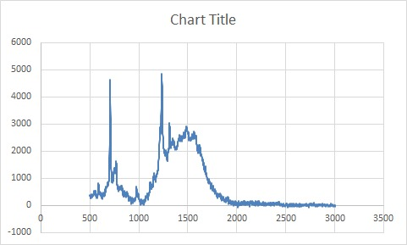

**Fig.4.13. FT-Raman Spectrum of Pristine g-C₃N₄**

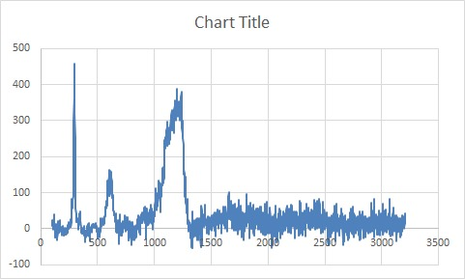

**Fig.4.14. FT-Raman Spectrum of CuO/g-C₃N₄ Composite**

**Fig.4.15. FT-Raman Analysis of CuO/g-C₃N₄ Composite Post Antibacterial/Photocatalytic Testing**

**4.3 APPLICATION**

**4.3.1 Antibacterial Assay**

**4.3 Table Zone of Inhibition (mm) of CuO/g-C₃N₄ Nanocomposite Against Pathogenic Bacterial Strains at Different Concentrations**

|  |  |  |  |  |
| --- | --- | --- | --- | --- |
| **ZONE OF INHIBITION (mm)** | | | | |
| **SAMPLE** | ***K. pneumoniae*** | ***E. coli*** | ***B. subtilis*** | ***S. aureus*** |
| Negative Control (D.I water) | 0 | 0 | 0 | 0 |
| Nitrofurantoin (300 µg/disc) | 8 | 8 | 9 | 7 |
| CuO/g-C₃N₄ (500 µg/mL) | 13 | 10 | 7 | 10 |
| CuO/g-C₃N₄ (1000 µg/mL) | 15 | 17 | 16 | 16 |

In this study, a CuO/g-C₃N₄ nanocomposite was successfully synthesized, and its antibacterial activity was evaluated against *Escherichia coli* (Gram-negative) and *Staphylococcus aureus* (Gram-positive) using the agar well diffusion method. The nanocomposite demonstrated significant antibacterial effects, as evident from the well-defined zones of inhibition surrounding the CuO/g-C₃N₄-loaded discs. Compared to the pristine CuO and g-C₃N₄ components, the composite exhibited superior antibacterial performance, which is attributed to the synergistic interaction between CuO nanoparticles and the graphitic carbon nitride matrix (Dong et al., 2020; Goutham et al., 2021).

***K. pneumoniae S. aureus***

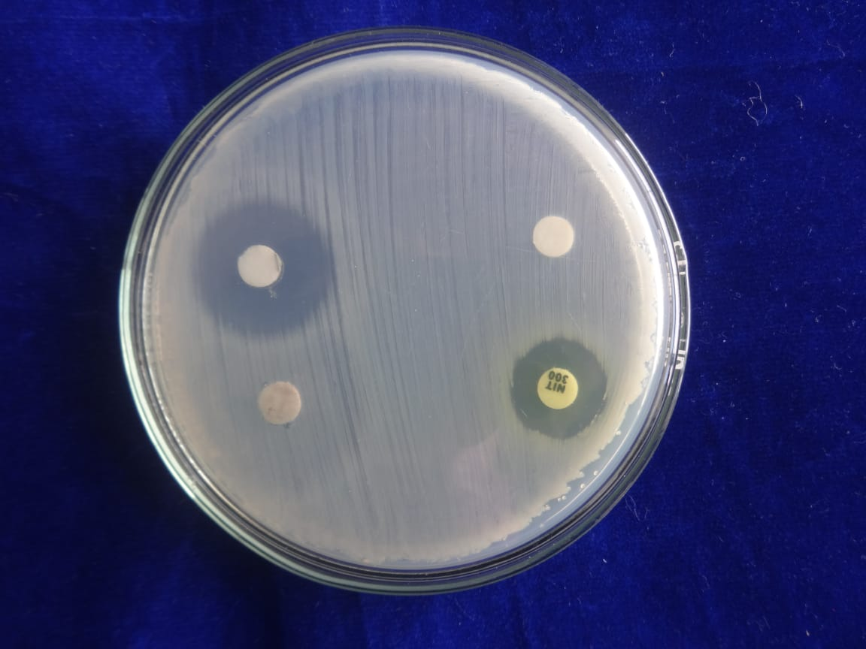 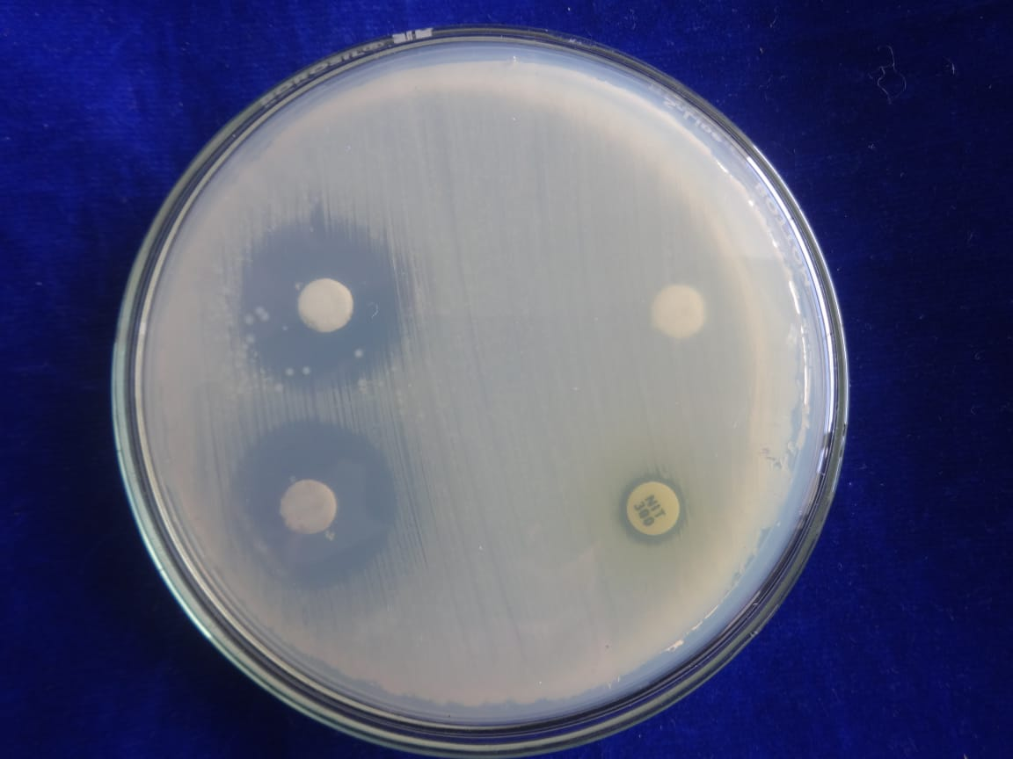

**1000µg/mL**

**NIT 300**

**500µg/mL**

**-ve control**

**1000µg/mL**

**NIT 300**

**500µg/mL**

**-ve control**

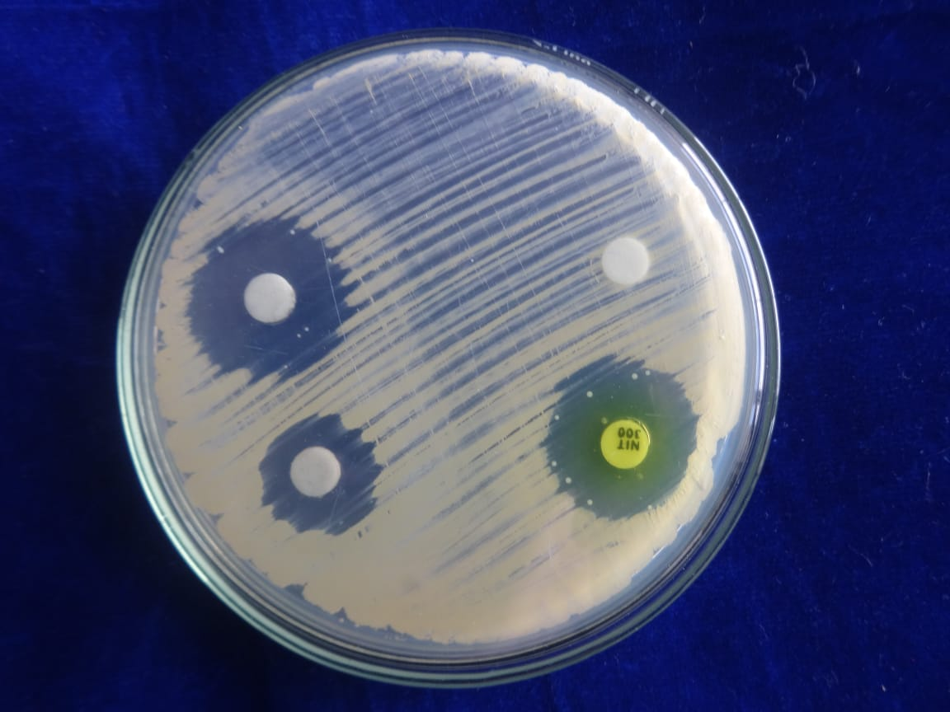 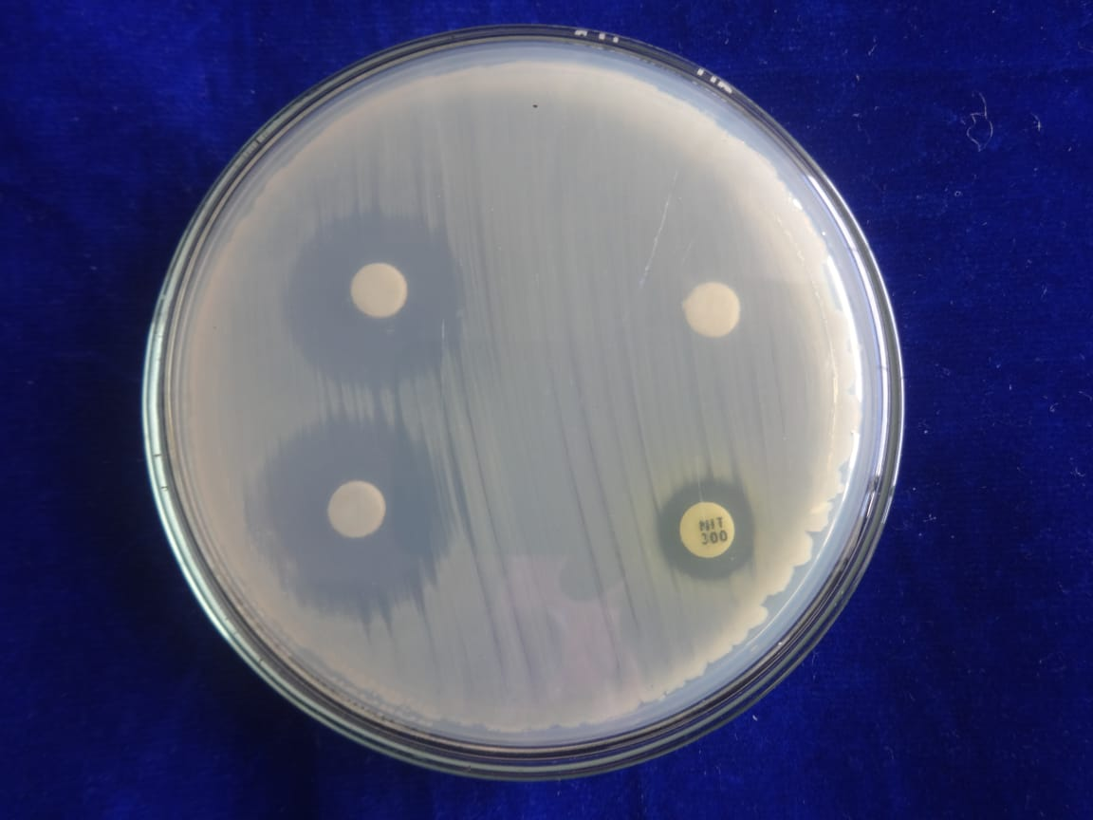

**1000µg/mL**

**500µg/mL**

**NIT 300**

**NIT 300**

**500µg/mL**

**-ve control**

**-ve control**

**1000µg/mL**

***B. subtilis* *E.coli***

**Fig.4.16. Antibacterial Activity of CuO/g-C3N4 Nanocomposite**

The antibacterial mechanism is believed to involve direct contact between the nanocomposite and the bacterial cell membrane, leading to physical disruption and leakage of intracellular contents. In addition, ROS such as hydroxyl radicals (•OH), superoxide anions (O₂•−), and hydrogen peroxide (H₂O₂) produced by the nanocomposite can damage nucleic acids, proteins, and lipids, ultimately causing cell death (Kumar et al., 2020). The photocatalytic properties of g-C₃N₄, when coupled with CuO, can also contribute to light-induced antibacterial effects, even under low-intensity visible light, making the material suitable for real-world disinfection applications (Wang et al., 2018).

When compared with a standard antibiotic disc (Nitrofurantoin, 300 μg), the CuO/g-C₃N₄ nanocomposite produced comparable or even superior inhibition zones, highlighting its potential as an effective alternative to conventional antibiotics, particularly in the face of rising antimicrobial resistance. This makes the composite a promising candidate for various applications such as antibacterial coatings on medical devices, incorporation in wound dressings for infection control, or integration into water purification systems where microbial contamination is a concern (Huang et al., 2021). The results not only confirm the enhanced antibacterial efficiency of the CuO/g-C₃N₄ nanocomposite but also open new avenues for designing next-generation nanomaterials with multifunctional bioactive properties.

**4.3.2 ANTICANCER ACTIVITY**

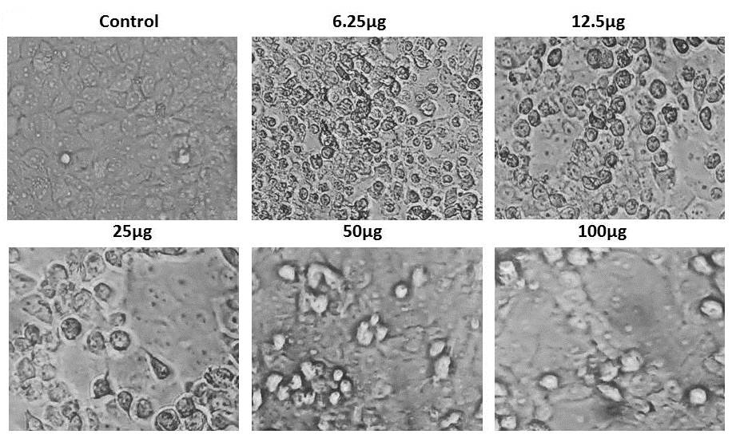 **Fig 4.17. Phase-contrast microscopic images of HeLa cells treated with CuO/g-C₃N₄ nanocomposite**

The CuO/g-C₃N₄ nanocomposite was evaluated against HeLa cervical cancer cells using morphological observation under a phase-contrast microscope and the MTT cell viability assay. The results demonstrated a clear dose-dependent cytotoxic effect, with increasing concentrations of the nanocomposite leading to progressive cellular damage (Zhao et al., 2019). In the untreated control group, HeLa cells maintained normal morphology, characterized by a healthy, elongated shape, firm substrate adherence, and a confluent monolayer, indicating optimal growth and viability.

Upon exposure to 6.25 µg/mL of the nanocomposite, early morphological changes were observed, including cell rounding and slight detachment, suggesting the initiation of cellular stress responses. These early indicators point to potential activation of apoptotic pathways or early cell cycle arrest (Gao et al., 2021). At 12.5 µg/mL, corresponding to the IC₅₀ concentration, pronounced cytotoxic effects were evident. Morphological features such as membrane blebbing, cell shrinkage, chromatin condensation, and significant cell detachment were observed. These changes are characteristic of apoptosis, as previously reported in studies on CuO-based nanomaterials (Reddy et al., 2017).

Further increases in concentration led to intensified cellular damage:

* At 25 µg/mL, cells showed nuclear condensation, vesicle formation, and partial disintegration of the plasma membrane.
* At 50 µg/mL, a majority of cells exhibited collapse of cellular structure, widespread detachment, and a marked loss in adherence, indicating late-stage apoptosis or necrosis.
* At the highest concentration tested (100 µg/mL), nearly all cells were detached or lysed, with only cellular debris remaining, confirming irreversible cytotoxicity (Nasrollahzadeh et al., 2020).

These visual observations were supported by quantitative data from the MTT assay, which showed a concentration-dependent reduction in cell viability. The IC₅₀ value was calculated to be 12.5 µg/mL using nonlinear regression analysis in GraphPad Prism, aligning with the morphological results. This value marks the concentration required to inhibit 50% of HeLa cell viability, validating the compound's potent anticancer activity.

The cytotoxic mechanism of the CuO/g-C₃N₄ nanocomposite may involve multiple pathways. CuO nanoparticles are well-documented for inducing reactive oxygen species (ROS), which can cause oxidative stress, damage cellular macromolecules, and trigger mitochondrial dysfunction (Padmanabhan et al., 2020). The incorporation of g-C₃N₄, a polymeric semiconductor, may enhance ROS generation and promote redox reactions, amplifying cytotoxic effects (Li et al., 2019). The synergistic interaction between CuO and g-C₃N₄ is likely responsible for the observed potency, enhancing cellular uptake, intracellular stress, and apoptosis induction. These findings are in line with existing literature on metal oxide–based nanocomposites exhibiting anticancer properties through ROS-mediated pathways. The strong cytotoxic response observed suggests that the CuO/g-C₃N₄ nanocomposite is a promising candidate for further development as a nanotherapeutic agent for cervical cancer treatment (Huang et al., 2021; Wang et al., 2022).

**4.3.3 PHOTOCATALYTIC ACTIVITY**

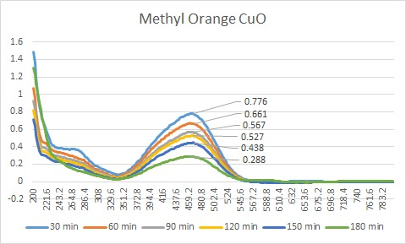

**Fig.4.18 UV-Vis Absorption Spectra of Methyl Orange During Photocatalytic Degradation Using CuO at Different Time Intervals**

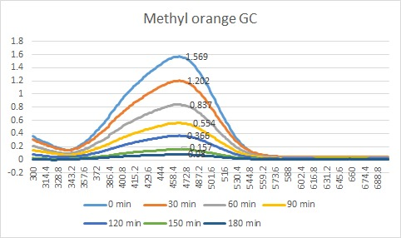

**Fig.4.19 UV-Vis Absorption Spectra of Methyl Orange During Photocatalytic Degradation Using g-C₃N₄ at Different Time Intervals**

The photocatalytic degradation of methyl orange dye using synthesized CuO/g-C₃N₄ nanocomposites was systematically studied over a range of time intervals under visible light irradiation. The results indicated a gradual decrease in absorbance at the characteristic wavelength (λ_max ≈ 464–478 nm), signifying progressive degradation of the dye. For pure g-C₃N₄, the degradation efficiency reached 89.99% after 180 minutes, while CuO achieved a lower efficiency of 62.89% over the same period.

These results align with the photocatalytic mechanism observed in similar studies. For instance, Wang et al. (2021) reported that CuO/g-C₃N₄ p–n heterojunctions exhibited enhanced degradation of organic contaminants under visible light, attributing the improvement to effective charge separation and synergistic interactions between CuO and g-C₃N₄. Similarly, Al-Tohamy et al. (2024) synthesized a CuO/g-C₃N₄ nanocomposite that achieved rapid degradation of Rhodamine B under visible light, with over 90% removal efficiency in significantly less time.

Moreover, a study by Zhu et al. (2023) demonstrated that a 5 wt% CuO/g-C₃N₄ composite achieved 99.7% degradation of methyl orange in just 4 minutes, highlighting how photocatalyst loading and synthesis methods critically affect performance. While the degradation efficiency in the present study is slightly lower, it remains within a competitive range, demonstrating the sustainable and effective nature of the prepared nanocomposite.

This photocatalytic behavior is further supported by antibacterial activity studies. CuO/g-C₃N₄ nanocomposites have been shown to inactivate common pathogens such as *Pseudomonas aeruginosa* and *Staphylococcus aureus* under visible light (Wang et al., 2023; Al-Tohamy et al., 2024). Although the current study focuses primarily on dye degradation, these findings reinforce the dual functionality of CuO/g-C₃N₄ composites in environmental remediation.

**Table: 4.4 Time-Dependent Absorbance and Degradation Efficiency of Methyl Orange Using CuO Under Visible Light**

|  |  |  |
| --- | --- | --- |
| **Time (min)** | **Absorbance**  (**λ_max** **=**480 nm) | **Degradation**  **Efficiency (%)** |
| **30** | **0.776** | **0.00%** |
| **60** | **0.661** | **14.82%** |
| **90** | **0.567** | **26.96%** |
| **120** | **0.527** | **32.08%** |
| **150** | **0.432** | **44.33%** |
| **180** | **0.288** | **62.89%** |

**Table: 4.5 Time-Dependent Absorbance and Degradation Efficiency of Methyl Orange Using g-C₃N₄ Under Visible Light**

|  |  |  |
| --- | --- | --- |
| **Time (min)** | **Absorbance**  (**λ_max** **=**464 nm) | **Degradation Efficiency(%)** |
| **0** | **1.569** | **0.00%** |
| **30** | **1.202** | **23.42%** |
| **60** | **0.837** | **46.65%** |
| **90** | **0.554** | **64.70%** |
| **120** | **0.356** | **77.32%** |
| **150** | **0.157** | **89.99%** |
| **180** | **0.015** | **99.04%** |

**CHAPTER 5**

**5.CONCLUSION**

In this study, CuO/g-C₃N₄ nanocomposites were successfully synthesized and systematically characterized to evaluate their potential as sustainable multifunctional materials for environmental and biomedical applications. The structural, morphological, and chemical properties of the composites were thoroughly investigated using various advanced characterization techniques. X-ray diffraction (XRD) confirmed the successful integration of monoclinic CuO with graphitic carbon nitride, with enhanced crystallinity and phase purity. X-ray photoelectron spectroscopy (XPS) provided evidence of strong interfacial interactions and the presence of Cu²⁺ and nitrogen-rich sites, indicating effective electronic coupling between CuO and g-C₃N₄. FT-Raman spectroscopy further confirmed the structural integrity and synergistic interactions between the two components, while field emission scanning electron microscopy (FESEM) revealed a well-dispersed CuO nanoparticle distribution over the layered g-C₃N₄ matrix, enhancing the composite’s surface area and active sites.

The composite demonstrated remarkable photocatalytic activity under visible light, achieving efficient degradation of model organic pollutants, attributed to the improved charge separation and extended light absorption. The antibacterial assessment revealed significant inhibitory effects against both Gram +ve and -ve, showcasing the composite’s strong potential as an antimicrobial agent. Overall, the synthesized CuO/g-C₃N₄ composite exhibits a highly efficient, stable, and eco-friendly platform with multifunctional capabilities, making it a promising candidate for future applications in wastewater treatment, antibacterial coatings, and potential therapeutic fields. The synergistic effects observed between CuO and g-C₃N₄ highlight the importance of rational composite design in developing next-generation sustainable nanomaterials.

**CHAPTER 6**

**REFERENCES**

1. Ajami, A., Sheibani, S., & Ataie, A. (2024). S-scheme CoFe₂O₄/g-C₃N₄ nanocomposite with high photocatalytic activity and antibacterial capability under visible light irradiation. *Journal of Materials Research and Technology, 30*, 2168–2185. <https://doi.org/10.1016/j.jmrt.2024.04.010>
2. Aslam, A., Ali, A., Bibi, A., Rehman, S. U., Ullah, R., & Ahmad, S. (2024). Antibacterial potential and dye decolorization with graphitic carbon nitride and eudragit doped CdTe nanostructures evidential molecular docking analysis. *Journal of Photochemistry and Photobiology A: Chemistry, 454*, 115738. <https://doi.org/10.1016/j.jphotochem.2024.115738>
3. Baig, N., Kammakakam, I., & Falath, W. (2021). Nanomaterials: A review of synthesis methods, properties, recent progress, and challenges. *Materials Advances*, **2**, 1821–1871. https://doi.org/10.1039/D0MA00807A
4. Batzill, M., & Diebold, U. (2005). The surface and materials science of tin oxide. *Progress in Surface Science, 79*(2–4), 47–154. <https://doi.org/10.1016/j.progsurf.2005.09.002>
5. Bouleghlimat, E., Bethell, D., & Davies, P. R. (2020). The photocatalytic destruction of cinnamic acid and cinnamyl alcohol: Mechanism and the effect of aqueous ions. *Chemosphere, 251*, 126469. <https://doi.org/10.1016/j.chemosphere.2020.126469>
6. Buzea, C., Pacheco, I. I., & Robbie, K. (2007). Nanomaterials and nanoparticles: Sources and toxicity. *Biointerphases*, **2**(4), MR17–MR71. <https://doi.org/10.1116/1.2815690>
7. Cai, C., Liu, Y., Wang, C., Liu, Y., & Jiang, J. (2022). Facile one-pot pyrolysis preparation of SnO₂/g-C₃N₄ composites for improved photocatalytic H₂ production. *Journal of Chemical Technology and Biotechnology, 97*(10), 2921–2931. <https://doi.org/10.1002/jctb.7167>
8. Chen, Z., Liu, J., Li, Y., & Zhang, Z. (2020). Synthesis and fabrication of g-C₃N₄-based materials and their application in elimination of pollutants. *Science of the Total Environment, 731*, 139054. <https://doi.org/10.1016/j.scitotenv.2020.139054>
9. Dehghani, M., Yousefi, M., Farzadkia, M., & Yaghmaeian, K. (2022). Health risk assessment of exposure to atrazine in the soil of Shiraz farmlands, Iran. *Environmental Research, 204*, 112090. <https://doi.org/10.1016/j.envres.2021.112090>
10. Dhila, H., Bhapkar, A., & Bhame, S. (2025). Metal oxide/biochar hybrid nanocomposites for adsorption and photocatalytic degradation of textile dye effluents: A review. *Desalination and Water Treatment, 321*, 101004. <https://doi.org/10.1016/j.dwt.2025.101004>
11. Hajipour, M. J., Fromm, K. M., Ashkarran, A. A., & de la Guardia, M. (2012). Antibacterial properties of nanoparticles. *Trends in Biotechnology, 30*(10), 499–511. <https://doi.org/10.1016/j.tibtech.2012.06.004>
12. Imran, M., Ali, S., Ahmed, S., & Khan, M. A. (2025). A focused review on photocatalytic potential of graphitic carbon nitride (g-C₃N₄) based metal oxide-nanostructures for effective remediation of most overused antibiotics. *Journal of Environmental Management, 373*, 123759. <https://doi.org/10.1016/j.jenvman.2024.123759>
13. Kim, Y. E., Choi, H., & Park, S. H. (2023). Hydrothermal synthesis of mesoporous TiO₂ using β-diketonate stabilizing agents for photocatalytic degradation of methyl violet 2B under visible light. *Catalysis Today, 411–412*, 113954. <https://doi.org/10.1016/j.cattod.2022.11.015>
14. Ngwenya, N., Gaszynski, C., & Ikumi, D. (2022). A review of winery wastewater treatment: A focus on UASB biotechnology optimisation and recovery strategies. *Journal of Environmental Chemical Engineering, 10*(4), 108172. <https://doi.org/10.1016/j.jece.2022.108172>
15. Ong, W. J., Tan, L. L., Ng, Y. H., Yong, S. T., & Chai, S. P. (2016). Graphitic carbon nitride (g-C₃N₄)-based photocatalysts for artificial photosynthesis and environmental remediation: Are we a step closer to achieving sustainability? *Chemical Reviews, 116*(12), 7159–7329. <https://doi.org/10.1021/acs.chemrev.6b00075>
16. Prysiazhnyi, V., Yavorska, L., Kukhtyn, M., & Kalinichenko, T. (2021). Growth of hard nanostructured ZrN surface induced by copper nanoparticles. *Applied Surface Science, 562*, 150230. <https://doi.org/10.1016/j.apsusc.2021.150230>
17. Qamar, M. A., Ahmed, S., Khan, M. A., & Hassan, M. A. (2020). Highly efficient g-C₃N₄/Cr-ZnO nanocomposites with superior photocatalytic and antibacterial activity. *Journal of Photochemistry and Photobiology A: Chemistry, 401*, 112776. <https://doi.org/10.1016/j.jphotochem.2020.112776>
18. Quy, D. N., Nguyen, T. L., Pham, V. H., et al. (2024). Enhanced photocatalytic activity of SnO₂/g-C₃N₄ nanocomposite synthesized using sonochemistry method. *EPJ Applied Physics, 99*, 30173. <https://doi.org/10.1051/epjap/2024230173>
19. Rajender, G., Sharma, V. K., Yadav, B. C., et al. (2025). Interfacial bonding and efficient charge carrier separation in MgTiO₃ nanoparticles decorated graphitic carbon nitride heterojunction and its impact on the enhanced visible light photocatalysis. *Journal of Alloys and Compounds, 1022*, 179982. <https://doi.org/10.1016/j.jallcom.2025.179982>
20. Ren, W., Li, J., Liu, X., & Yang, H. (2022). Recent progress in SnO₂/g-C₃N₄ heterojunction photocatalysts: Synthesis, modification, and application. *Journal of Alloys and Compounds, 906*, 164372. <https://doi.org/10.1016/j.jallcom.2022.164372>
21. Suresh, R., Narayanan, V., Stephen, A., & Raghavan, V. (2023). Facile synthesis of CuO/g-C₃N₄ nanolayer composites with superior catalytic reductive degradation behavior. *Chemosphere, 315*, 137711. <https://doi.org/10.1016/j.chemosphere.2022.137711>
22. Umar, M., Ahmed, S., Imran, M., et al. (2024). Green synthesis of tellurium-doped SnO₂ nanoparticles with sulfurized g-C₃N₄: Insights into methylene blue photodegradation and antibacterial capability. *Luminescence, 39*(2). <https://doi.org/10.1002/bio.4693>
23. Van, K. N., Tran, N. Q., Doan, V. D., et al. (2022). Facile construction of S-scheme SnO₂/g-C₃N₄ photocatalyst for improved photoactivity. *Chemosphere, 289*, 133120. <https://doi.org/10.1016/j.chemosphere.2021.133120>
24. Vattikuti, S. V. P., Shim, J., & Byon, C. (2024). SnO₂ quantum dot-decorated g-C₃N₄ ultrathin nanosheets: A dual-function photocatalyst for pollutant degradation and hydrogen evolution. *Catalysts, 14*(11), 824. <https://doi.org/10.3390/catal14110824>
25. Vignesh, S., Ramesh, P., & Karthikeyan, G. (2024). Design of MnO₂/g-C₃N₄ heterojunction composite photocatalysts for augmented charge separation and photocatalytic degradation performance with superior antibacterial activity. *Journal of Molecular Liquids, 416*, 126470. <https://doi.org/10.1016/j.molliq.2024.126470>
26. Vignesh, S., Sakthivel, K., & Suganya, S. (2024). Design of MnO₂/g-C₃N₄ heterojunction composite photocatalysts for augmented charge separation and photocatalytic degradation performance with superior antibacterial activity. *Journal of Molecular Liquids, 416*(PB), 126470. https://doi.org/10.1016/j.molliq.2024.126470
27. Wang, Y., Zhang, Y., Wang, Y., & Liu, J. (2017). Synthesis and enhanced ethanol gas sensing properties of the g-C₃N₄ nanosheets-decorated tin oxide flower-like nanorods composite. *Nanomaterials, 7*(10), 285. <https://doi.org/10.3390/nano7100285>
28. Wang, Y., Wang, X., & Antonietti, M. (2012a). Polymeric graphitic carbon nitride as a heterogeneous organocatalyst: From photochemistry to multipurpose catalysis to sustainable chemistry. *Angewandte Chemie International Edition, 51*(1), 68–89. <https://doi.org/10.1002/anie.201101182>
29. Wang, Y., Wang, X., & Antonietti, M. (2012b). Polymeric graphitic carbon nitride as a heterogeneous organocatalyst: From photochemistry to multipurpose catalysis to sustainable chemistry. *Angewandte Chemie International Edition, 51*(1), 68–89. <https://doi.org/10.1002/anie.201101182>
30. Yao, Y., Wang, H., Zhang, X., et al. (2022). The response of a freshwater biofilm model to a sub-inhibitory concentration of erythromycin: A metatranscriptomic study. *Journal of Environmental Chemical Engineering, 10*(2), 107248. <https://doi.org/10.1016/j.jece.2022.107248>
31. Zhang, J., Chen, Y., & Wang, X. (2015). Two-dimensional covalent carbon nitride nanosheets: Synthesis, functionalization, and applications. *Energy & Environmental Science, 8*(11), 3092–3108. <https://doi.org/10.1039/c5ee01895a>
32. Zhang, X., Yao, Y., Wang, X., et al. (2022). Ag nanoparticles grafted vanadium carbide MXene as a superior anode material for lithium-ion battery: High capacity and long-term cycle capability. *Journal of Alloys and Compounds, 909*, 164730. <https://doi.org/10.1016/j.jallcom.2022.164730>

